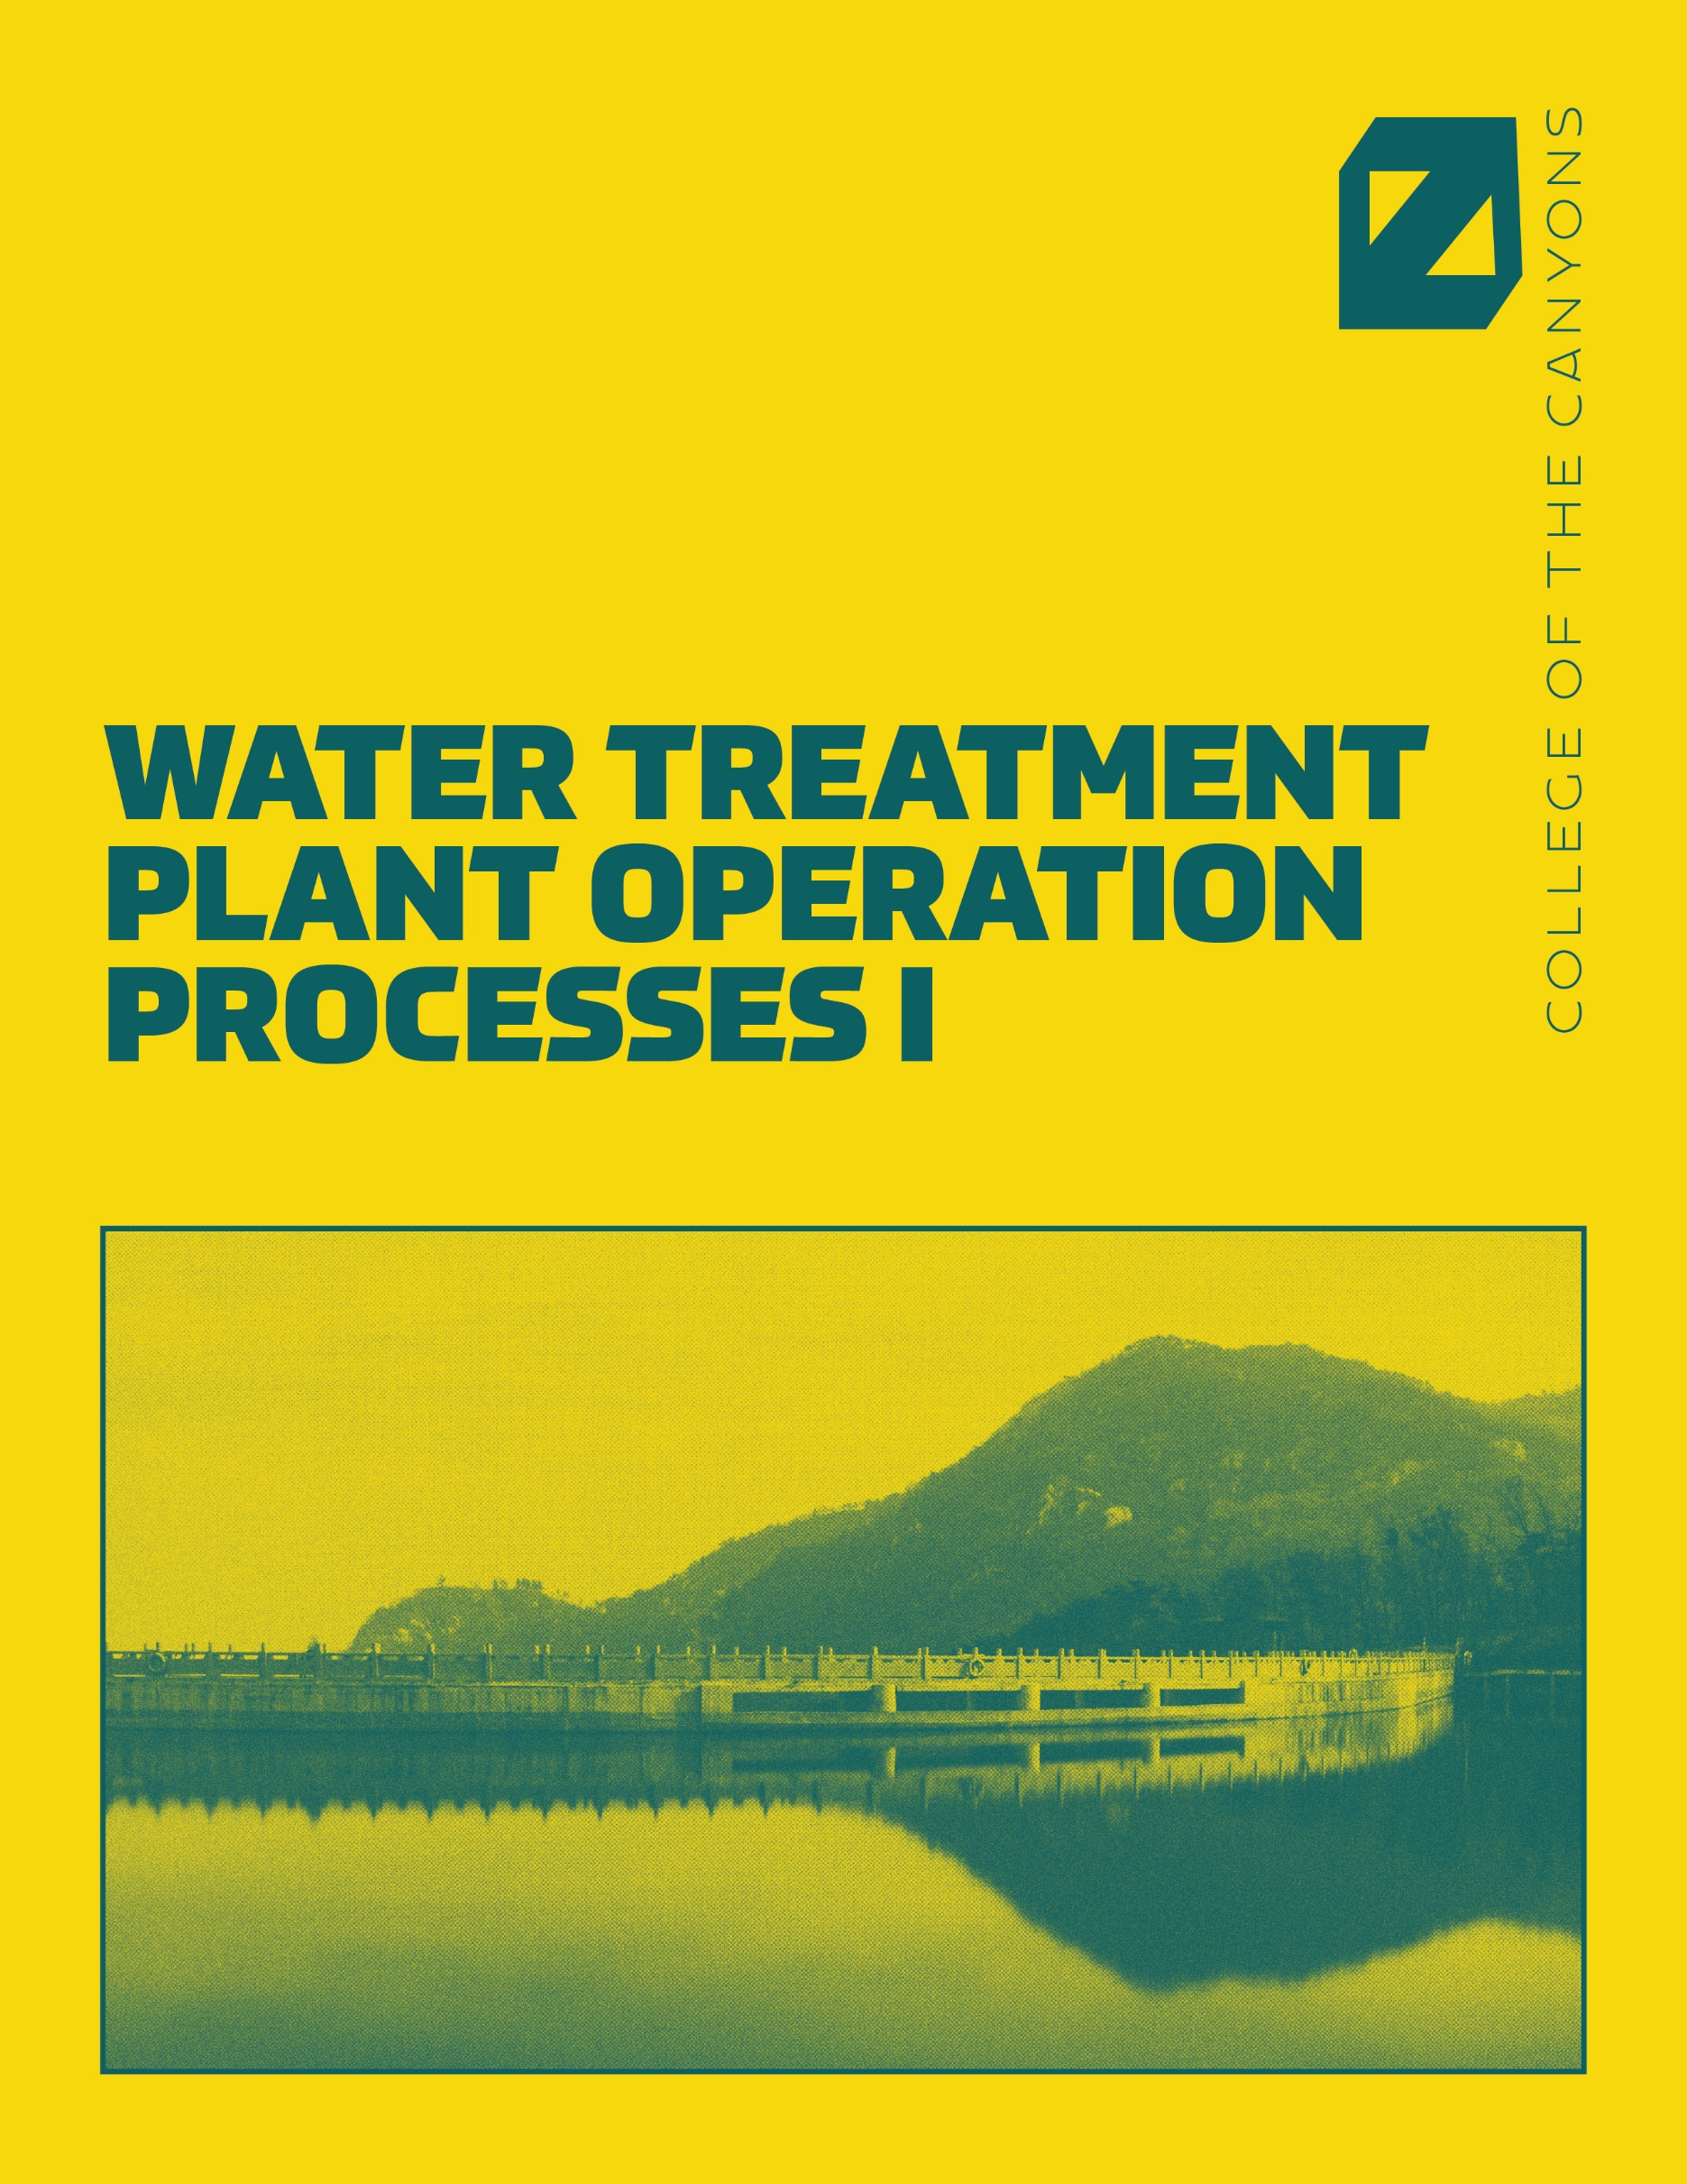

Water Supply and Demand in California

An Open Educational Resources Publication by College of the Canyons

Created by Vincent Titiriga

Editor: Alexa Johnson
Cover: Ian Joslin

Version 1.3

2019

Acknowledgements

College of the Canyons would like to extend appreciation to the following people and organizations for allowing this textbook to be created:

California Community Colleges Chancellor’s Office
Chancellor Dianne G. Van Hook
Santa Clarita Community College District
College of the Canyons Distance Learning Office

© 2018, California Community Colleges, Chancellor’s Office.
This work is licensed under a Creative Commons Attribution 4.0 International License.

Table of Contents

Chapter 1 – Source Water Quality 5
Chapter 2 – Water Chemistry and Standards 20
Chapter 3 – Microorganisms 33
Chapter 4 – Coagulation and Flocculation 45
Chapter 5 – Sedimentation 56
Chapter 6 – Filtration 66
Chapter 7 – Disinfection 81
Chapter 8 – Chlorine 91
Chapter 9 – Chloramination and Nitrification 100
Chapter 10 – Laboratory 108

Chapter 1 – Source Water Quality
A very finite amount of water on our planet (0.34%) is available to treat for human consumption. Knowing where the water comes from assists certified operators in treating raw source water to make it potable. Newer technology has been developed to treat salinized or salty water found in the ocean. These treatment methods are still extremely expensive and not widely accessible. Supplying water to the public is an extremely important function in society as water is the basic building block of life. Because water quality is of the utmost importance new regulations and water quality standards are continually changing and evolving to make sure the public has safe sources of drinking water. The first drinking water standards were written in the Safe Drinking Water Act (SDWA), which was signed into law by President Ford in 1974. Throughout the text new concepts will be introduced and an acronym will be given and used subsequently. You are going to learn to love acronyms if you become a certified operator. We use them quite frequently!
After reading this chapter you should be able to identify and explain the following:
- The Earth’s Hydrologic Cycle
- Sources of groundwater
- Sources of Surface Water
- Water math: Area and Unit Conversions
The Hydrologic Cycle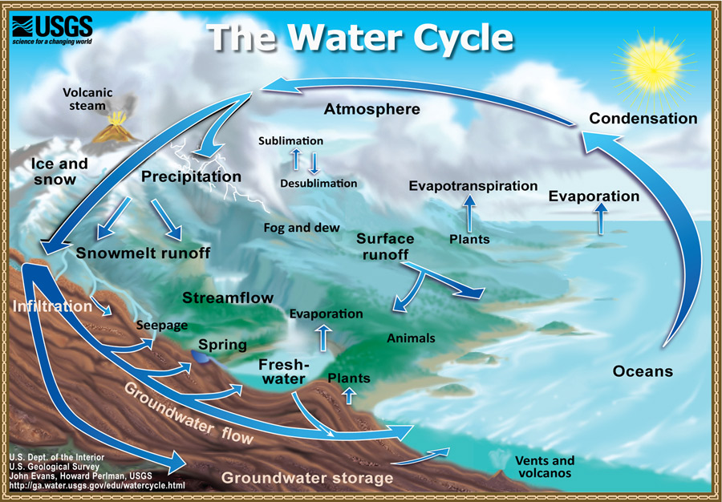
The Water Cycle by the USGS is in the public domain
The Hydrologic cycle is the continual movement of water on the surface of the planet. The water moves above, below, and across the Earth’s surface as a liquid, gas, or solid. The 12 elements of the hydrologic cycle are defined as follows:
- Evaporation- Water moves in the gas state from the Earth’s surface to the atmosphere
- Transpiration- Water moves in the gas state from plants to the atmosphere.
- Advection- Water in the gas state moves through air currents in the atmosphere
- Condensation- Water vapor converts from gas to liquid state in the form of water droplets.
- Precipitation- Water as a liquid and/or solid falls from the atmosphere. We commonly refer to this as rain, snow, sleet, and hail.
- Interception- Water in the liquid state that is captured by plants
- Infiltration- Water in the liquid state that soaks into the surface of the ground. This will be what is known as groundwater which will be detailed later in this chapter.
- Subsurface Flow- Water in the liquid state flows below the Earth’s surface. The movement is generated by gravity and obstructions below the surface of the Earth.
- Runoff- Water in the liquid form travels to bodies of water. This would include the ocean, lakes, rivers, and streams. This is also known as surface water which will be detailed more later in this chapter.
- Channel flow- Water in the liquid form that flows from small channels into rivers and streams
- Storage-. Water is naturally stored in liquid form in lakes, ponds, wetlands, and groundwater aquifers. In solid form water is naturally stored in ice, snow, and glaciers. This natural storage provides much of the water treated for human consumption.
- Snowmelt- Water in the solid form converts to water in the liquid form and is returned to the hydrologic cycle. Note: In California, snowpack is a critical water supply indicator as it is the melting snowpack that recharges rivers and the general supply of water
There are other important terms to note in regard to the hydrologic cycle. The surface to atmosphere movement of water is known as evapotranspiration. This is the combination of evaporation and transpiration from plant life to the atmosphere. The most widely known movement of water is precipitation which is when water in various physical states falls from the atmosphere to the surface of the Earth. The movement of water from the surface to subsurface is known as percolation. Percolation might also be referred to as infiltration or recharge. These terms are commonly associated with underground aquifers. Finally, surface to surface flow is called runoff.
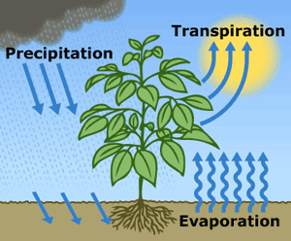
Image by the USGS is in the public domain - Evapotranspiration is the sum of evaporation from the land surface plus transpiration from plants. Precipitation is the source of all water.

Groundwater
Groundwater is one of the two main sources of storage used by municipalities to produce potable water. It is formed by the percolation (infiltration and/or recharge) of water from the surface of the earth to the subsurface. Water moves through holes and cracks in the subsurface and collects in an underground aquifer. An aquifer is a geologic formation that accumulates water due to its porousness. Important characteristics of groundwater include consistent water quality and the ability to remain safe from surface contamination. With greater technology and testing methods chemicals and constituents known to be harmful to humans have been found in numerous well sites throughout the United States. Wells close to industrial areas have been contaminated with harmful chemicals and substances. New regulations are continually being updated to ensure source groundwater is safe to drink. In normal circumstances very little treatment is required to yield groundwater.
The Groundwater Treatment Rule (GWTR) was enacted in 2006 to prevent microbial contamination from underground water supplies. The purpose of the new rule was to classify water systems that were at a greater risk for fecal contamination. These systems must employ a multiple barrier protection similar to the surface water treatment rule which will be covered in more detail in the next section.
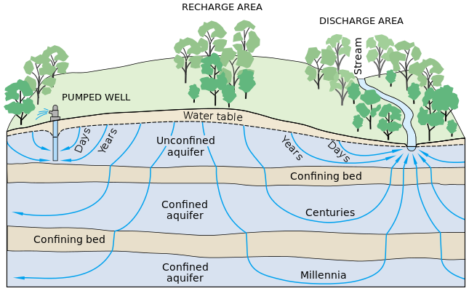
Image by the USGS is in the public domain
There are two kinds of aquifers, confined and unconfined. In an unconfined or water table aquifer the water table is free to rise and fall. The water table in unconfined aquifers rise and fall depending on the amount of precipitation which recharges the aquifer. Confined aquifers, also known as artesian wells, contain water that is confined due to layers of low permeability. These layers, which restrict movement, are comprised of rock or hard clay and are referred to as confining beds, aquitards, or aquicludes. Artesian wells are generally under pressure when drilled. Once drilled the water level at which the column of water will rise is known as the piezometric surface. Sometimes the water will rise to the surface or past the surface but in the instance the water remains below it is known as a non-flowing artesian well.

Wells
The construction of wells is critical in the extraction of water from underground water supplies. Placement of wells is very important because proper location will produce the greatest yield. Important terms related to underground wells:
- Static Water Level- the level in the well when no water is being removed from the aquifer. This level can be measured in feet or elevation.
- Pumping water level- The level when water is being removed from the aquifer. This level can vary depending on the rate of flow from the well.
- Drawdown- The difference between the pumping water level and the static water level
- Cone of depression- The shape or “cone” created by the movement of water in all directions during pumping.
- Zone of influence- The area of water affected by the drawdown of water during pumping. It is important to note that wells cannot be placed too closely together because their zones of influence may affect each other.
- Well yield- the amount of water drawn from an aquifer over a specific period of time
- Specific capacity- The amount of water produced per drawdown expressed in gpm/ft
- Safe Yield/Perennial yield- The amount of water that can be pulled from an aquifer per year without a drop in the water table
- Overdraft- Too much water removed. Greater than the safe yield of a well
- Subsidence- The permanent drop in the water table due to overdraft

Specific Capacity calculation
Specific capacity = Flow (GPM) ÷ Drawdown (FT)
Example: A well has a yield of 600gpm and the drawdown is 50 ft. What is the specific capacity of the well?
Specific Capacity = 600 GPM ÷ 50FT = 12

Surface Water
Throughout the United States surface water is the most widely used source of water for large cities and other municipalities. Groundwater is not as widely available so is not a sufficient water supply for major cities. Surface water includes lakes, ponds, rivers, and streams. California is unique as the southern half of the state has 2/3 of the population but only 1/3 of the available water and the northern half of the state has 1/3 of the population but 2/3 of the water. Snowpack in northern California is critical to the state’s water supply. Most of Southern California is very arid and densely populated so water travels from Northern California through the State Water Project to Southern California.
Surface runoff supplies water for all surface water sources. Influences of surface runoff include intensity of rainfall, duration of rainfall, composition of soil, amount of moisture in soil, slope of the ground, vegetation coverage, and human influences. One would think that a lot of rain would be ideal. However, if the rainfall density is too great, more water can be lost because the ground will no longer absorb the water. The same applies to the duration of rainfall. A prolonged rain even makes the soil too moist and unable to capture water. Vegetation coverage and the slope of the ground are very important to stopping runoff. If the slope of the ground is steep, the speed of runoff is increased. Vegetation slows the speed of runoff and allows more water to absorb or infiltrate into the ground. Human influences have a great impact on water runoff. Impervious surfaces like concrete entirely prevent infiltration.

Natural Watercourses

Key Terms
Natural water courses include rivers, creeks, streams, washes, and arroyos. They flow in one of three ways:
- Perennial streams - Watercourses which flow continuously throughout the year. Ex: Colorado River
- Ephemeral streams - Watercourses that flow sporadically, generally after rainfall. Ex: Santa Clara River which runs through Santa Clarita and Ventura County
- Intermittent - Watercourses which flow somewhere between ephemeral and perennial streams. Rainfall and high groundwater levels will affect how often these streams flow.
Rivers and Streams are a good water supply source but are not necessarily the best source for public water supplies.
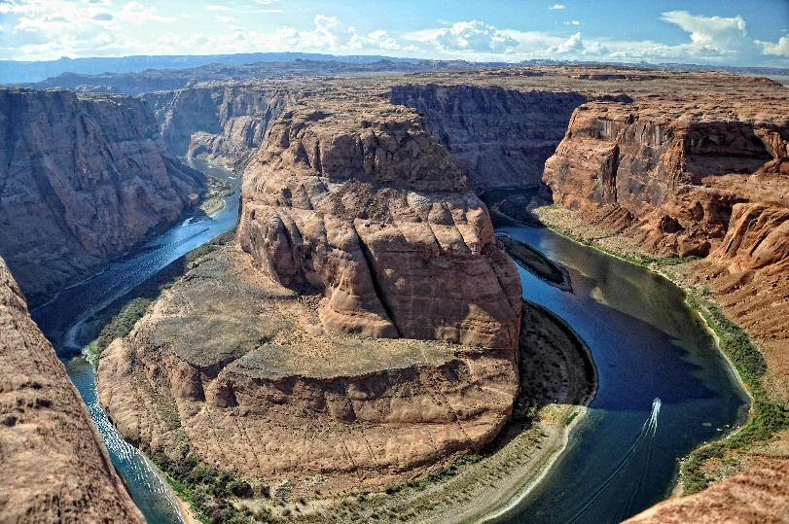 | 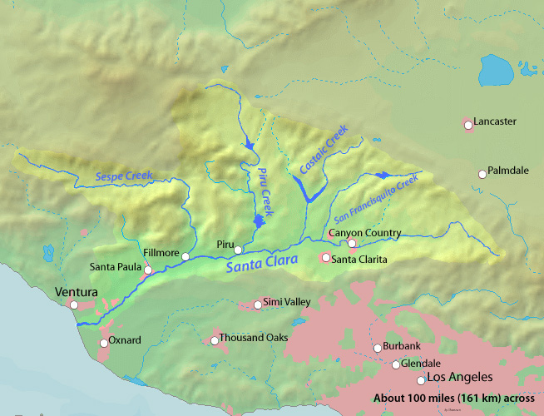
Image of the Colorado River by Paul Hermans is licensed under CC BY-SA 3.0 | Santa Clara River Map by Shannon1 is in the public domain

Lakes
Lakes are the most widely used public water supply source. However, very few “natural” lakes exist. Most lakes used for public water supply are man-made and use a dam to create the lake and contain the water. This is known as an impoundment. Water from these lakes is piped to treatment facilities. Due to variances in temperature lakes develop “layers” also known as stratification. Denser, colder water will drop to the bottom (Benthic zone) of a lake during the summer. There are three layers:
- Epilimnion - The strata closest to the surface
- Hypolimnion - The strata near the bottom
- Thermocline - middle strata with greatest variance in temperature
Lake turnover will occur during seasonal temperature changes. When the temperature of a lake is uniform it is known as isothermal. Algae growth is a serious problem that causes taste and odor issues in treated water. Copper sulfate can be added to a lake to help remedy algae blooms. In severe cases the water undergoes eutrophication which is the loss of oxygen. Complete or extreme oxygen depletion can kill all living creatures in the water including animals and fish.
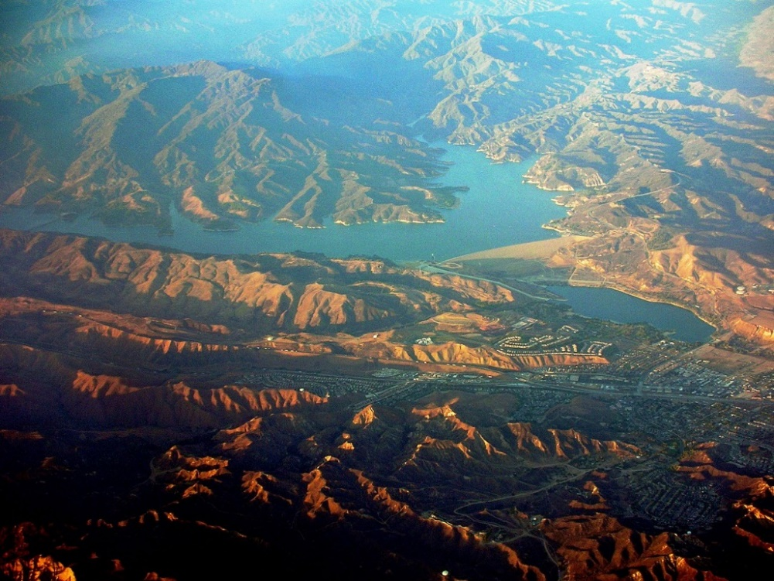
Image of Castaic Lake by Rehman is in the public domain

Introduction to Water Math
Mathematics is a key component in water treatment. Operators use conversion tables and basic algebra to complete many daily tasks. Charts are available on the State Water Resources Control Board website that assist operators with most calculations you would find on the state exams or while on the job. Below is a list of basic units and their respective conversion factors:
Table 1.1: Units and Conversion Factors
Measurement | Equivalent
1 cubic foot of water | 62.3832lbs
1 gallon of water | 8.34lbs
1 liter of water | 1,000 grams
1 mg/L | 1 part per million (ppm)
1 ug/L | 1 part per billion (ppb)
1 mile | 5,280 feet
1 yard | 3 feet
1 yard³ | 27ft³
1 acre | 43,560 square feet or ft²
1 cubic foot or ft³ | 7.48 gallons
1 gallon | 3.785 Liters or L
1 L | 1,000 milliliters (ml)
1 pound | 454 grams

Working with Fractions
$$\frac{\text{Numerator}}{\text{Denominator}}$$
$\frac{4}{4}=\frac{1}{1}$ or =1 $\frac{4}{2}=\frac{2}{1}$ or =1

Rounding
Rounding the number 324.179
3 = Hundreds | The above number (324.179) rounded to the nearest tenth would be 324.2. Since the number in the hundredth place is at or above 5, the number in the tenth place is rounded up. If you were rounding this number to the nearest whole number it would be 323 since the number in the tenth place is below 5.
4 = Tens
9 = Units
1 = Tenth
7 = Hundredth
9 = Thousandth

Unit Dimensional Analysis
This is the most important function in most water math problems. Make sure to always place your factors in the proper place or the equation will be impossible to solve correctly. The example below will use unit measurements. Water operators will commonly convert between different units of measurement.

Example 1
Convert 48 inches into feet. (There are 12 inches in a foot.)
$$\frac{48 \text{inches}}{1}×\frac{1 \text{foot}}{12 \text{inches}}=\frac{4 \text{ft}}{1}$$
Drop the one from the denominator and the answer is 4 ft.
The same process will be to convert between gallons and cubic feet.

Example 2
Convert 22.44 gallons into cubic ft. or ft³ (There are 7.48 gallons in one cubic foot.)
$$\frac{22.44 \text{gallons}}{1}×\frac{1 \text{ft}\text{³}}{7.48 \text{gallons}}=\frac{3 \text{ft}³}{1}$$
Drop the 1 from the denominator and your answer is 3 ft³

Example 3
How many gallons are there in a tank which holds 300ft³ of water?
$$\frac{300\text{f}{\text{t}}^{\text{3}}}{1}×\frac{7.48 \text{gal}}{1\text{f}{\text{t}}^{\text{3}}}=2,244 \text{gallons}$$

Area
Area will be important for many applications in water math. It may be necessary to calculate the area of a tank that requires painting or an area of ground cover near equipment.
Rectangles | Area = L X W
Circle  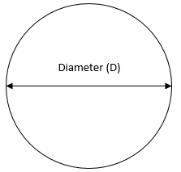 | Area = 0.785 × D²
Trapezoid  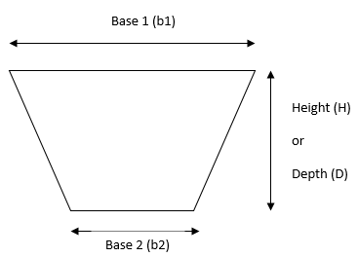 | Area = X H
Example 1
A wall that is 10ft wide and 40ft in length needs to be painted. What is the total square feet of the wall?
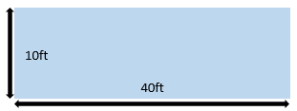 | Area = Length x Width  Area = 10ft x 40ft  Area = 400ft²
Example 2
What is the area of the top of a circular storage tank that is 100 feet in diameter? (Note: Use the formula .785 x d². In most cases in water math we will always be dealing with the diameter and not the radius. These short cuts will help as the problems become more difficult. In this problem I will demonstrate why we will use this formula and not the standard mathematical equation for solving area problems.)

Equation #1 Area= π (3.14) x r² (100ft ÷ 2 = 50 to find radius)
Area = 3.14 x 50 x 50
Area = 7,850 ft²
Equation #2 Area= .785 x d²
Area = .785 x 100 x 100
Area = 7,850 ft²

In this example the first equation was easy to solve because we were working with a pretty friendly number. As the equations become more difficult we do not want to take the extra step to divide the diameter by two to solve for the radius. If the diameter of the tank was 357ft, this problem would have been slightly more difficult using the first equation.

Example 3
The top of a circular storage tank needs to be painted. It is 100 ft. in diameter. Each gallon of paint covers approximately 200 square feet. How many gallons of paint will you need to buy?
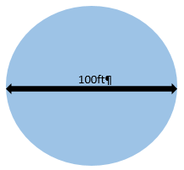 | Area= .785 x d²  Area= .785 x 100ft x 100ft  Area= 7,850 ft²  $$\frac{7850 \text{ft}²}{1}x\frac{1 \text{gal}}{200 \text{ft}²}=39.25 \text{gal}$$

Chapter Review
- What is the middle layer of a stratified lake called?
  - Thermocline
  - Benthic Zone
  - Epilimnion
  - Hypolimnion

- What is the conversion of liquid water to gaseous water known as?
  - Advection
  - Condensation
  - Precipitation
  - Evaporation

- Water weighs
  - 7.48 lbs/gal
  - 8.34 lbs/gal
  - 62.4 lbs/ft³
  - Both B. and C.

- What is the static level of an unconfined aquifer also known as?
  - Drawdown
  - Water Table
  - Pumping Water Level
  - Aquitard

- What is the cause of taste and odor problems in raw surface water?
  - Copper sulfate
  - Blue-green algae
  - Oxygen
  - Lake turnover

- What chemical reduces blue-green algae growth?
  - Chlorine
  - Caustic Soda
  - Copper Sulfate
  - Alum

- A water bearing geologic formation that accumulates water due to its porousness
  - Aquifer
  - Lake
  - Aquiclude
  - Well

- What kind of stream flows continuously throughout the year?
  - Ephemeral
  - Perennial
  - Intermittent
  - Stratified

- The surface to atmosphere movement of water is known as
  - Precipitation
  - Percolation
  - Stratification
  - Evapotranspiration

- An aquifer that is underneath a layer of low permeability is known as
  - Confined aquifer
  - Water Table aquifer
  - Unconfined aquifer
  - Unreachable groundwater

- What is the middle layer of a stratified lake known as?
  - Hypolimnion
  - Benthic Zone
  - Thermocline
  - Epilimnion

- The amount of water that can be pulled from a aquifer without depleting
  - Drawdown
  - Safe yield
  - Overdraft
  - Subsidence

Math Questions
Please show all work. On the State exams you will not get credit if work is not shown.
- What is the area of the top of a storage tank that is 75 feet in diameter?
  - 4,000 ft²
  - 4416 ft²
  - 1104 ft²
  - 17,663 ft²

- What is the area of a wall 175 ft. in length and 20 ft. wide?
  - 3,000 ft²
  - 2,500 ft²
  - 3,500 ft²
  - 4,000 ft²

- You are tasked with filling an area with rock near some of your equipment. 1 Bag of rock covers 250 square feet. The area that needs rock cover is 400 feet in length and 30 feet wide. How many bags do you need to purchase?
  - 40 Bags
  - 42 Bags
  - 45 Bags
  - 48 Bags

Chapter 2 – Water Chemistry and Standards
Water treatment is a complex process that involves parts that the human eye cannot see. In this chapter you will learn about the basic scientific principals related to the water treatment. We will also discuss drinking water standards in the United States and different community standards. After reading the chapter the student should be able to identify:
- Matter, elements, and compounds
- Public water systems: community and non-community
- Primary and secondary standards
- Water treatment violations
- Volume math problems

Matter, Elements, and Compounds

Matter
The smallest parts of an element are comprised of particles known as atoms. Even though they are so small, atoms still retain the characteristics of the element. Even with technological advancements, microscopes are still unable to capture atoms. The multiple arrangements of atoms make each element unique. The atom ever so small, is comprised of three particles known as the proton, neutron, and electron. Each particle is associated by different charges.
- Proton-positive
- Neutron-no charge
- Electron- Negative charge
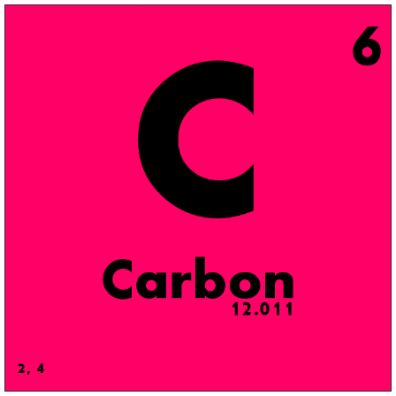 | 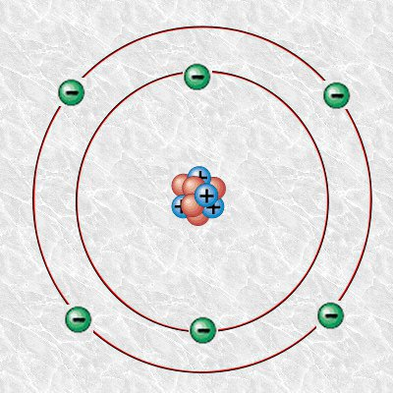
Carbon by Science Activism is licensed under CC BY 2.0 | Carbon atom by Alejandro Porto is licensed under CC BY-SA 3.0
The defining characteristic of an atom is identified by the proton. The proton, located in the nucleus, has a distinctive number. For example, carbon has six protons located in the nucleus. No other element has six protons in the nucleus. The number of protons is represented as the atomic number. The atomic weight is the number of protons and neutrons. The number of protons that exist for a given element is always the same, but the number of neutrons can vary. When there is a varying number of neutrons of a given element, it is known as an isotope. When an atom has a difference in electrons, it is called an ion. When the charges of the atom are not balanced, they become unstable. An atom that has more protons than neutrons is called a cation. An atom that has more electrons than protons is called an anion.
Most common elements in the water treatment profession:

- Aluminum (Al)
- Antimony (Sb)
- Arsenic (As)
- Barium (Ba)
- Beryllium (Be)
- Boron (B)
- Bromine (Br)
- Cadmium (Cd)
- Calcium (Ca)
- Carbon (C)
- Chlorine (Cl)
- Chromium (Cr)
- Copper (Cu)
- Fluorine (F)
- Hydrogen (H)
- Iodine (I)
- Iron (I)
- Lead (Pb)
- Magnesium (Mg)
- Manganese (Mn)
- Mercury (Mn)
- Nickel (Ni)
- Nitrogen (N)
- Oxygen (O)
- Phosphorus (P)
- Potassium (K)
- Radium (Ra)
- Selenium (Se)
- Silicon (Si)
- Silver (Ag)
- Sodium (Na)
- Strontium (Sr)
- Sulfur (S)
- Thallium (Tl)

There are elements that are pure in form, such as oxygen. Since elements are unstable, they often combine with other elements to form compounds. Water (H₂O), for example, is a compound. It is a combination of two hydrogen atoms and one oxygen atom. A compound is two or more elements that are bonded together due to their attraction by reverse charges. The combining elements form a molecule. When two chemicals are mixed together without a chemical reaction it is called a mixture. The difference between a mixture and a compound is a compound is bonded together by a chemical reaction. A good example of a mixture is salt water. The salt can be removed from the water through distillation. Water chemistry will be covered in greater detail in the Water Quality text and course.

Drinking Water Standards
The first drinking water standards created in the United States occurred in 1974 and were called the Safe Drinking Water Act (SDWA). The US EPA sets drinking Water Standards that all Water Municipalities must adhere to. Although States are able to come up with their own Standards, they must meet the minimum requirements set forth by the federal EPA. In California, drinking water standards are much more stringent than the federal requirements and therefore have primacy. As of 2014 the State regulatory group responsible for drinking water is the State Water Resources Control Board. Revisions to the safe drinking water act include approval techniques for treatment plants, specifying criteria for filtration of public water supplies, distinguishing different treatment techniques for surface and ground water, and prohibiting lead products in drinking water systems. There are two sets of drinking water Standards identified as primary standards and secondary standards. Primary Standards effect human health and are mandated with Maximum Contaminant Levels (MCL). The MCL is the official safe level at which a human can consume the given contaminant without adverse health effects. Secondary Standards do not affect human health and are controlled with Maximum Contaminant Level Goals. (MCLG). When a contaminant is reported, there is no such thing as zero. Levels are set to protect human health but are also set based on the best available technology. As technology improves MCL’s may be reexamined. Instrumentation to measure contaminant levels are not always capable of reading to absolute zero. Because of this a Detection level for reporting is required.

Public Water Systems
There are three different categories of public water systems:
- Community Public Water System: A community public water system has 15 or more service connections and serves at least 25 or more people year round. These would include municipalities, mobile home parks, condos, and apartment buildings.
- Nontransient, NonCommunity System: A nontransient, NonCommunity public water system owns their own system and serves an average of 25 people for at least six months. Schools, hospitals, and office buildings are included in this category.
- Transient, NonCommunity System: A transient, NonCommunity public water system owns their own water system and serves an average of 25 people per day. In this category people consume the water for a short period of time. This category includes churches, parks, restaurants, and motels.
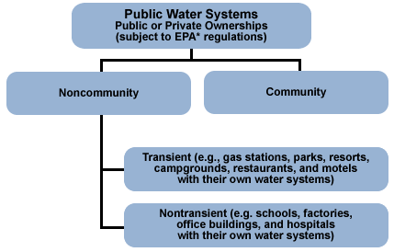
Image by the CDC is in the public domain
Primary Drinking Water Standards are split into five categories. The categories include Inorganics, Organics, Turbidity, Microbiological, and Radiological.
- Inorganics: Metals, Nitrate, and Fluoride
- Organics: Pesticides, solvents, and Disinfectant byproducts (DBP’s)- The combination of Chlorine and natural organic material. This topic will be discussed in greater detail later in the text.
- Turbidity: The cloudiness of the water. Turbidity has the ability to shield microbiological material.
- Microbiological: coliform testing (This will be covered in greater detail later in the text. Water operators do not test for specific microbiological agents. We test for the indicator organism coliform. They colonize in greater numbers so if a sample comes back positive there is a greater likelihood of fecal contamination.)
- Radiological: gross alpha, beta, and radon
Secondary drinking water standards are solely based on the aesthetic quality of drinking water. The main focus of secondary standards is taste, odor, and color. A glass of water that smells like fish and is orange in color may be “safe” to drink but wouldn’t be well received or readily consumed. California as well as some other states has endorsable secondary standards.

Table 2.1: Recommended Levels for Contaminants and Characteristics
Contaminant/characteristic | Recommended level
Aluminum | 0.05 to 0.2 mg/L
Chloride | 250 mg/L
Color | 15 color units
Copper | 1 mg/L
Corrosivity | Non-corrosive
Fluoride | 2 mg/L
Foaming agents | 0.5 mg/L
Iron | 0.3 mg/L
Manganese | 0.05 mg/L
Odor | 3 threshold odor number
pH | 6.5 to 8.5
Silver | 0.10 mg/L
Sulfate | 250 mg/L
Total dissolved solids | 500 mg/L
Zinc | 5 mg/L
Source: Graph by the EPA is in the public domain

Public Notification
In the event that a treatment plant does not meet requirements of the SDWA the public must be notified. There are three different tiers of notification with tier I being the worst of violations and tier III being the least. The EPA provides very specific language for public notifications in the event of a violation. Violating a SDWA compliance is bad enough, but failing to report violations brings even stiffer penalties and fines. In 2014 in Flint Michigan 15 people were criminally charged due to their negligence in the water treatment profession. It all started when the city of Flint changed their source water without properly testing. Officials knew the water was not safe to drink and numerous violations had been made. The public was not properly informed of these violations which resulted in 10 deaths and 77 others becoming severely ill. It is something that is rarely discussed because people in industrialized countries never really worry about the quality of their drinking water. The most important thing you can do as an operator is say something if there appears to be a problem with the quality of the drinking water. Otherwise you may end up in jail. Notification options include radio or television announcements, newspapers, hand delivery, posting in public places, loudspeakers, texting, and reverse 911. The notification will vary based on the severity of the violation.

Violations

Tier I
- Any positive fecal coliform positive test and failure to sample after initial positive test.
- Nitrate or Nitrite violation
- Chlorine Dioxide Maximum residual disinfection limit
- Exceed treatment plants allowable turbidity level. Can be a tier II if the primacy agency does not elevate violation
- Waterborne emergency or outbreak of waterborne illness

Tier II
- MCL, MRDL and, Treatment Technique (TT) violations if treatment plant does not perform corrective actions to fix issues in treatment plant or fails to inform public.
- Water quality monitoring violation - not taking required water quality samples. Can also be a tier III violation but can be elevated for gross negligence
- Noncompliance of a variance or an exemption

Tier III
- Water testing and monitoring violation
- Any time the treatment system is running under a variance or exception. Primacy agency may give a treatment plant a variance or exemption for a short period of time. The public notification is to inform the public that a water agency is not running in accordance with an approved treatment technique. It doesn’t mean the water is unsafe to drink, but the operating manuals are very specific.

Water Quality monitoring
Continuous monitoring of drinking water ensures quality; reliable drinking water is being delivered to the public. The number of samples taken, frequency of sampling, sampling location, testing procedures, and requirements for record keeping are all specified by state and federal requirements. If sampling requirements are not met, it can lead to public notification. The tier violation is based on the contaminant and whether or not the contaminant causes acute health effects.
The type of monitoring is based on the source of the water, the treatment technique, and the size of the system. Reporting and record keeping is based on the primacy agency’s regulations. The States regulations must meet federal requirements at a minimum but may be more stringent as is the case in California.

Record Keeping
Below is a list of records that must be kept and the amount of time the records must be retained on file.
- Bacteriological and Turbidity- 5 years
- Chemical analysis- 10 years
- Corrective actions from violations- 3 years
- Sanitary surveys- 10 years
- Exemptions- 5 years after expiration

Variances and Exemptions
In the event a water system is unable to meet a MCL because of the source water, a primacy agency can grant a variance or exemption. The variance is only given when the agency has incorporated the best available technology and there is zero risk to public health. In the case of Flint Michigan, the new source water was not properly tested before it was used in the system. Flint Water plant was unable to properly treat the source water which had elevated levels of lead and the City was not using the best available technology. Even if the City of Flint would have applied for a variance or exemption, it would not have been granted because the lead levels in the water create a significant risk to public health.
In future chapters of the text we will examine regulations added to the SDWA. Several changes and enhancements have been made since the exception of the original legislation. We will discuss in greater detail the Total Coliform Rule, Surface Treatment Water Rule, Long Term 2 Enhanced Surface Water Treatment Rule, Lead and Copper Rule, Ground Water Rule, and Stage 1 &2 Disinfectant Bi-Product Rule.

Volume
Volume calculations will become very common for water treatment operators. Operators use volume calculations to solve math questions with circles, triangles, and rectangles. If you look around a water treatment facility, it is full of geometric shapes. Tanks can be cylindrical or rectangular in nature. Settling ponds may have a triangular nature to them. The basic volume questions will become more involved later on in the text as you may have to solve a volume question first, and then solve a flow related question.
Cylinder  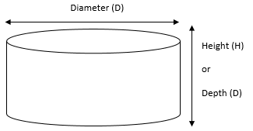 | Volume = 0.785 × D² × H
Rectangle  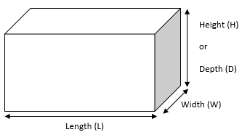 | Volume = L × W × H
Trapezoid  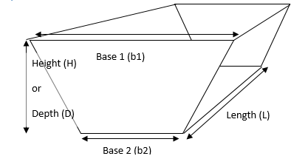 | Volume = × H × L

Example 1
What is the volume of a cubed tank that is 10 feet high? (Remember cubes have the same unit of length on all three sides. This is the easiest problem to solve.)
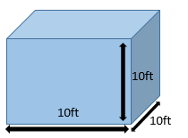 | Volume = Length × Width × Height  Volume (Ft³) = 10ft × 10ft × 10ft  Answer is 1,000 ft³

Example 2
What is the volume of a rectangular tank that is 20 ft. high, 10 ft. wide, and 7ft. in length?
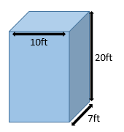 | Volume= Length × Width × Height  Volume= 7ft. × 10ft. × 20ft.  Answer is 1,400ft³
There are two different ways to solve cylindrical math problems. The easiest formula to use is volume= .785 d² H. This formula is easiest because in water math we are generally looking at the diameter of a cylindrical shape and not the radius. The radius of a circle is half the diameter. It is a straight line measured from the center of the circle to the edge of the circle. The diameter is a straight line that passes through the center of the circle with end points on the circle.

Example 3
What is the volume of a storage tank that measures 40 ft. in diameter and is 20 ft. deep?
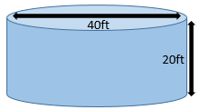 | Volume= .785 × d² × H  Volume= .785× 40ft. × 40ft. × 20ft.  Answer is 25,120ft.³

Often the water math word problems will require multiple steps to solve. Typically, we want to know how many gallons a given tank will hold. Once we find the volume of the tank in cubic feet, we will then convert the cubic feet into gallons.

Example 4
Convert the answer from Example 3 into gallons.
$\frac{25,120 \text{ft}\text{³}}{1}×\frac{7.48 \text{gal}}{1 \text{ft}\text{³}}=\frac{187,898\text{ gal}}{1}$
Answer: 187,898 gallons

Example 5
A rectangular water tank is full. The dimensions are 30ft high 12ft wide and a length of 10 ft. Convert to gallons.
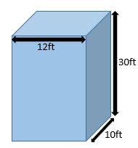 | Volume= 10ft x 12ft x 30 ft  Volume= 3,600ft³  $\frac{3,600 \text{ft}³}{1}×\frac{7.48 \text{gal}}{1 \text{ft}\text{³}}=\frac{26,928 \text{gal}}{1}$  Answer: 26,928 gallons

Example 6
A cylindrical storage tank has a diameter of 50ft. and a height of 30ft. The tank is half full. How many gallons are in the tank?
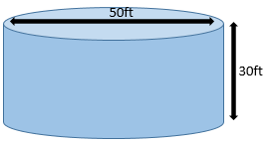 | Volume= .785 x 50ft. x 50ft. x 15ft.  Volume= 29,437.5 rounded to 29,438ft³  $\frac{29,438 \text{ft}\text{³}}{1}×\frac{7.48 \text{gal}}{1 \text{ft}\text{³}}=\frac{220,196 \text{gal}}{1}$  Answer: 220,196 gallons

Chapter Review
- The smallest part of an element is known as what?
  - Proton
  - Neutron
  - Atom
  - Nucleus

- The atomic weight is comprised of?
  - Neutrons and electrons
  - Protons and neutrons
  - Nucleus and neutrons
  - Atom and nucleus

- Atom with a negative charge
  - Proton
  - Neutron
  - Nucleus
  - Electron

- What does the symbol mg/L stand for?
  - Micrograms per liter
  - Milligrams per/L
  - parts per million
  - Both B & C

- What does the acronym MCL stand for?
  - Minimum contaminant level
  - Micron contaminant level
  - Maximum contaminant Level
  - Milligrams counted last

- How long do sanitary surveys have to be retained for records?
  - 3 years
  - 5 years
  - 7 years
  - 10 years

- The most severe water system violation that requires the fastest public notification
  - Tier I
  - Tier II
  - Tier III
  - Tier IV

- The primacy agency may grant a variance or exemption as long as
  - The agency is using the Best Available Technology
  - There is no threat to public health
  - There is never a scenario for a variance or exemption
  - Both A. and B.

- A public water system that serves at least 25 people six months out of the year
  - Nontransient noncommunity
  - Transient noncommunity
  - Community public water system
  - None of the above

- Regulations based on the aesthetic quality of drinking water
  - Primary Standards
  - Secondary Standards
  - Microbiological Standards
  - Radiological Standards

- The lowest reportable limit for a water sample
  - 0.5 mg/L
  - Zero
  - Public health goal
  - Detection Level for reporting

- Primary Standards are based on
  - Color and Taste
  - Aesthetic quality
  - Public Health
  - Odor

- A circular clearwell is 150 feet in diameter and 40 feet tall. The Clearwell has an overflow at 35 feet. What is the maximum amount of water the clearwell can hold in Million gallons rounded to the nearest hundredth?
  - MG
  - 4.62 MG
  - 18.50 MG
  - 7.50 MG

- A sedimentation basin is 400 feet length, 50 feet in width, and 15 feet deep. What is the volume expressed in cubic feet?
  - 100,000 ft³
  - 200,000 ft³
  - 300,000 ft³
  - 400,000 ft³

- A clearwell holds 314,000 ft³ of water. It is 100 ft in diameter. What is the height of the clearwell?
  - 25 ft
  - 30 ft
  - 35 ft
  - 40 ft

Chapter 3 – Microorganisms
The most important job of a Water Treatment Operator is providing reliable and quality water to the public. This is accomplished through chemical deactivation or physical removal of disease causing microorganisms in the water. Microorganisms are deactivated by the addition of a chemical such as Chlorine or Ozone while physical removal is accomplished with the use of a filtration system.

Surface Water Treatment Rule
The Surface Water Treatment Rule (SWTR) was created in 1990 to further protect the public from waterborne illness. The specific diseases the SWTR seeks to prevent are those caused by viruses, legionella, and Giardia lamblia. Disease causing microorganisms are also known as pathogens. The microbes that cause most waterborne illnesses are found in most surface water in the United States. Every public agency that uses surface water as source water must adhere to the SWTR. Surface Water is defined as any open body of water that is susceptible to surface runoff. Rainfall and snowmelt that enters open bodies of water such as lakes, rivers, and man-made reservoirs is susceptible to contamination from sewage treatment plants and animal feces.
At this time there are no simple inexpensive tests for viruses, legionella, and Giardia lamblia; therefore, other protective measures are used to test the source water and treated water. Water regulations provide detailed inactivation and removal regulations for Protozoa, also known as Giardia, and viruses. Bacteria fall somewhere in the middle of both microorganisms so there is no need to “regulate” them. Bacteria will be removed and/or deactivated within the parameters or regulations that are in place. Giardia and Cryptosporidium form hard cysts that are very difficult to deactivate chemically with Chlorine. They are larger than viruses so they or more easily removed through filtration. Newer technological advances such as ozone addition are excellent ways to deactivate Giardia.
Treatment plants must use a combination of disinfectant (chemical deactivation) and filtration and must achieve 99.9% removal or inactivation of Giardia cysts and 99.99% of viruses. You might also see the percentages expressed as 3 Log and 4 Log. 99.9% will be expressed as 3 Log and 99.99% will be expressed as 4 Log. Treatment plants which use filtration achieve their removal factor by monitoring the combined filter effluent turbidity. Turbidity is the measurement of the cloudiness in water. The reason it is important to measure turbidity is because microorganisms can hide behind the very small particles and render treatment techniques ineffective. Turbidity readings are expressed as nephelometric turbidity units (NTU). Most surface source water will not meet standards that would enable a treatment plant to refrain from using approved filtration techniques. The approved treatment techniques currently used by water operators are conventional treatment, direct filtration, slow sand, diatomaceous earth, reverse osmosis, and alternate treatment technologies approved on a case by case basis by the primacy regulating board. Newer technologies such as membrane filtration and UV treatment are being employed by some water agencies.
Table 3.1: Waterborne Pathogens
Bacteria | Viruses | Protozoa
- Campylobacter  - Escherichia coli (E-coli)  - Salmonella  - Yersinia  - Vibrio  - Legionella  - Aermmonas  - Mycobacterium  - Shigella  - Pseudomonas | - Hepatitis A  - Reovirus  - Calicivirus  - Enterovirus  - Coxsackievirus  - Adenovirus  - Echovirus  - Poliovirus | - Giardia Lamblia  - Cryptosporidium  - Entameoba  - Microsporidium

A continuous disinfectant residual must always be in the distribution system to prevent waterborne illness. A disinfectant residual of .2 mg/L must be present at all times in the distribution system, however most water operators will maintain somewhere between 2.5 mg/L-3.0 mg/L. The CT calculation is used to make sure proper disinfectant levels are being used during the treatment and distribution process. The effectiveness of the treatment process is calculated with the CT formula and uses data such as disinfectant used, residual of disinfectant, length of time disinfectant is in contact with water, water temperature, and pH of the water. It is important to note that during the treatment process the goal is to disinfect the water (kill all pathogens) and not to sterilize (kill all organisms).
The “C” is the concentration of disinfectant while the “T” is the amount of time the disinfectant is in contact with water. On days with higher effluent plant rates an operator may need to raise chlorine doses as the disinfectant will be in contact with the water for less time. Conversely, if plant flow rates are lower, a lower chlorine dose can be used because the disinfectant is in contact with the water for a greater time.

Case Study: Milwaukee April 1993
In April of 1993 the largest outbreak of Cryptosporidium on record occurred in Milwaukee, Wisconsin. Over 400,000 people reported illness and 100 people died. All of the people who died after drinking the tainted water had the AIDS virus. It can’t be for certain that the Cryptosporidium was the cause of each of their deaths, but as will be discussed later in this chapter, people with weakened immune systems are much more susceptible to death if they drink tainted water.
The Milwaukee incident was the catalyst for enhancements to the SWTR. Since Cryptosporidium creates cysts and is not killed by chlorine, the “double barrier” treatment approach was created. Treatment plants were then required to monitor turbidity effluent levels and use alternative treatment techniques, such as ozone or ultra violet light, that would deactivate the Cryptosporidium. An effective filtration plant using coagulation, flocculation, sedimentation, and filtration, should have been able to handle the outbreak, thus turbidity levels were not within standards.
The source of the Cryptosporidium was believed to be a sewage spill that was very close to the intake of the Southern Milwaukee treatment plant where the outbreak occurred. Others believe that the operators of the treatment plant were using higher quantities of waste stream water in the treatment process. Recycling washed filter water is a common practice, but after this event it was established that only 10% of the sourced raw water can come from the waste water.
The lessons everybody learned here is water quality is ever-changing and evolving. Mother Nature throws curveballs at us that change the quality of the source water. If something is wrong, it is your duty as an operator to say something. Regulations are all well and good but if they are not being followed, people can become very ill or possibly even die.

Total Coliform Rule
The total coliform rule was published in 1989 and was revised in 2014. It set up minimum requirements for the frequency and amount of coliform tests that would be taken by water agencies. As discussed earlier, the coliform bacteria exist in larger quantities than other bacteria. If there is a positive coliform test, there is a greater chance the treatment process is not functioning properly and there is an increased chance of pathogens in the water. Bacterial outbreaks in water cause gastroenteritis with the associated symptoms of nausea, diarrhea, vomiting, and cramps. Very young people, elderly, and people with weakened immune systems are at an even greater danger should there be waterborne illnesses in water. Each water agency is required to have an approved sampling site map approved by the primacy agency.
The Total Coliform Rule goal is zero positive coliform samples. Water systems that take less than 40 samples per month are only allowed one positive sample while systems which take greater than 40 samples must not find positive results in more than 5% of the coliform samples taken. If a positive coliform sample is found, it is not necessarily an indicator of a problem. Human sampling error could be the culprit. Once a positive is found the coliform sample is retaken within 24 hours at the positive sampling site and two additional samples are taken, one upstream and one downstream of the initial positive site. If there is a second positive coliform result, the water is then tested for E-Coli. If E-Coli is present in the sample, it is an immediate public health risk and is deemed an acute MCL violation. This would be considered a Tier I violation and public notification would have to occur within 24 hours.

Long-Term 1 Enhanced Surface Water Treatment Rule
The Long-Term 1 Enhanced Surface Water Treatment Rule (LT1ESWTR) applies to water systems which serve less than 10,000 people. Below is a list of requirements for water agencies which fall under this category.
- Must achieve 99% or 2 log removal of Cryptosporidium
- Most systems are required to meet turbidity standards of 0.5 NTU from 95% of combined filter effluent turbidity readings. Smaller systems will get 2 log removal credit of Giardia with a stricter .03 NTU combined filter effluent.
- Monitoring of individual filter is required. Higher turbidity reading from individual filters will require corrective action.
- Some states might require a disinfectant byproduct profile
- Any change in primary disinfectant must be profiled and approved
- All treated water clearwells must be covered and not open to atmosphere.

Long-Term 2 Enhanced Surface Water Treatment Rule
The Long Term 2 Enhanced Surface Water Treatment Rule (LT2ESWTR) covers all water systems which serve more than 10,000 customers.
- This rule added enhancements to the SWTR. Water providers are required to test the source raw water for Cryptosporidium and E-coli for a 2 year period. This step was put in to ensure all treatment plant equipment was capable of properly deactivating and removing pathogens from water.
- After testing, systems were given a bin number which determined how susceptible the system was to contamination.
- If systems were susceptible, a time frame was given to correct deficiencies
- Continuous monitoring of the distribution system influent and maintaining at least .02 mg/L chlorine residual is required

Filter Back Wash Recycling Rule
As noted in the Milwaukee case study, water systems are able to use recycled waste water as a raw water source. Many treatment plants utilize waste ponds, waste lagoons, and waste basins to capture recycled wash water and water from drains throughout treatment plant. In order for plants to use the recycled water, plants must put the waste water through the same treatment process as raw untreated water. The amount of water that can be returned is based on the plants size and maximum plant flows.

Lead and Copper Rule
The lead and copper rule differs from most other water guidelines because these two constituents are usually found in water after it has gone through the treatment cycle. Most raw water has very low levels of lead and copper. Lead and copper are found in drinking water after a chemical reaction takes place in distribution pipes. Water that is more acidic can erode lead and copper pipes causing them to leach into water. The use of lead pipes in drinking water systems was banned in 1986 and they can no longer be used. Lead is known to cause several health problems in fetuses and young children. It can cause developmental problems. Lead can also have effects on the kidney, brain, red blood cells, and is known to cause anemia.
With optimal corrosion control, the ability of water to chemically react with lead and copper pipes is lowered. Many treatment plants add chemicals such as caustic soda to raise the pH of the water. Treated water with a pH around 8 will keep a thin layer of calcium on the inside of a distribution pipe which protects the pipe from corrosion. Corrosion control is tested by monitoring the conductivity, testing pH of water, water temperature, testing for calcium, testing for alkalinity, and testing for phosphate or silica corrosion inhibiter if used to control corrosion.
The Lead and Copper rule also differs from other rules because it bases its parameters on action levels. If 10 percent of the customers’ water tests in the 90th percentile of the action level for lead and copper, then further preventative actions must be met. Most customers do not have to worry about this due to advances in corrosion control in the past few decades.
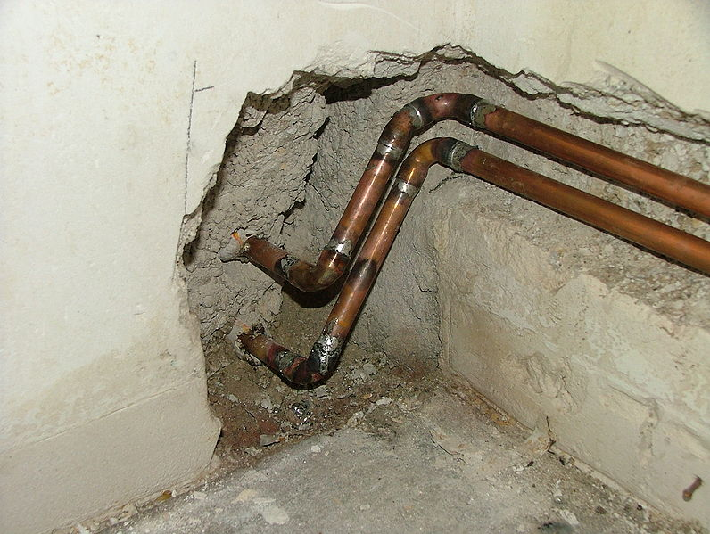
Image of lead pipes by Borsi112 is licensed under CC BY-SA 3.0

Stage 1 and 2 Disinfectant Bi-Product Rule
When natural organic matter mixes with chemical disinfectants, it is possible for disinfectant byproduct formation (DBP). Chemical disinfectants used in water treatment that form DBP’s are chlorine, chlorine dioxide, chloramines, and ozone. The Stage 1 disinfectant byproduct rule established MCL’s for trihalomethane (TTHM), haloacitic acid (HAA5), chlorite, and bromate. Compliance is set up on a running annual average for TTHM, HAA5, and Bromate and on a monthly average for chlorite. The rule also set up maximum disinfection levels for chlorine, chloramines, and chlorine dioxide.
The Stage 2 disinfectant byproduct rule applies to all community and nontransient noncommunity water systems that add a chemical disinfectant or purchase treated water that has a chemical disinfectant. The purpose of the Stage 2 rule is to monitor local sampling of individual connections. Some parts of the water system have less movement, therefore they are more susceptible to DBP formation. The Stage 2 rule covers TTHM and HAA5 and has the same MCL as the Stage 1 rule. See chart on the following page:
Disinfectant Residual | MRDL* as mg/L | Compliance Based On
Chlorine | 4.0 mg/L | Running annual average RAA
Chloramines | 4.0 mg/L | Running annual average RAA
Chlorine Dioxide | 0.8 mg/L | Daily samples
*Maximum residual disinfectant level
Disinfection Byproduct | Maximum Contaminant Level | Compliance Based On
Trihalomethane | .080 mg/L (80 ppb) | Running annual average
Haloacetic acid | .060 mg/L (60 ppb) | Running annual average
bromate | .010 mg/L (10 ppb) | Running annual average
chlorite | 1.0 mg/L (1 ppm) | Monthly average
*ppb- parts per billion ppm- parts per million

Consumer Confidence Reports
The public has a right to know what is in their drinking water. As you continue to read through the text you will notice that a lot of the terminology is quite a mouthful. In 1998 consumer confidence reports were made available to the public for transparency. Eight groups of information were added to the report:
- System information including contact info
- Different sources of water (i.e. lakes, wells, rivers)
- Definitions non water personnel can understand including MCL’s, MCLG’s and treatment techniques
- Any detected contaminants in system along with a listing of the possible health effects if limits and goals are not met
- Non-regulated contaminants found
- List of violations if they occurred
- Variances and exemptions
- Educational tools for contaminants and effected populations
The internet has made it possible for water treatment facilities to post information monthly on company websites; however a consumer confidence report will be mailed/electronically delivered to its customers on a yearly basis.

Flow Rate Calculation
The flow rate calculation will be one of the most frequently used in water math. This calculation tells us a lot about what is going on in our water system. Common flow rates you will see are Gallons per Minute (GPM), Cubic Feet Per Second (CFS), Million Gallons a Day (MGD), and Acre Feet per Year (AFY). Water operators use flow rates for different purposes. If you were running a small treatment plant, you might use GPM or CFS in your day to day operations but when looking at water produced throughout the entire month or year, calculating in Acre Feet may be more appropriate. Like any algebraic formula there will be an unknown factor you are solving for. In the case of a flow question, there will be 3 values, two known and one unknown.
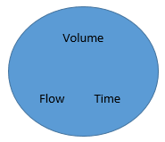 | Flow Rate Equation  Flow Rate = Volume ÷ Time  The algebraic “Wheel” is a very effective way to solve many water math problems. Those students with more “mechanical” minds may find this way of solving math problems easier. Below is an example of how to solve a flow rate equation with both methods.

Example 1
In 4 hours a water tanks volume increases by 30,000 gallons. What was the flow rate of the water entering the tank? Express in gallons per minute.
$\text{Flow Rate=}\frac{\text{Volume}}{\text{Time}}$ $F\text{low Rate=}\frac{\text{30,000 gallons}}{\text{4 Hours}}$ $\frac{ 7,500 \text{gallons}}{1 \text{Hour}}$ $\frac{\text{7,500 gallons}}{1 \text{Hour}}=\frac{\text{1 Hour}}{\text{60 min}}$  $$=\frac{\text{125 gallons}}{\text{minute}}$$ | 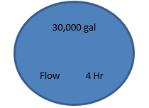 | 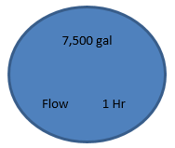
We can also use the Flow Rate calculation to solve for volume or time.

Example 2 - Solve for Time
How long will it take to drain a 100,000 gallon storage tank where the water is exiting at 2,500 Gallons per minute?
$Time=\frac{100,000 \text{gal}}{2,500\text{ GP}\text{M}}$ $=\frac{\text{40 minutes}}{}$
(Always put the unknown in the left part of the formula so your factors cancel out properly.

Example 3 - Solve for Volume
Your water tank pump is set to run for 90 minutes. Your pump output is 3,000 GPM. How many gallons of water will enter the tank?
$\text{Volume}=3,000 \text{GPM} x 90 \text{min}$
Volume= 270,000 gallons

Example 4
A water tank’s full capacity is 500,000 gallons. The operator will bring the tank down to half full in an 8-hour period. What is flow rate of the water exiting the tank?
(Note: The state gets very creative with their test questions. Remember to read the question multiple times before solving. Don’t be the test taker that uses 500,000 gallons in the equation instead of 250,000 gallons!)
$\text{Flow Rate}=\frac{\text{250,000 gallons}}{\text{8 hours}}$ $\text{Flow Rate}=\frac{\text{31,250 gallons}}{\text{1 Hour}}$
$\frac{\text{31,250 gal}}{\text{1 }\text{Hour}}\text{=}\frac{\text{1 }\text{Hour}}{\text{60 min}}$ = 520.83 GPM

Chapter Review
- A disease causing microorganism
  - Pathogen
  - Colilert
  - Pathological
  - Turbidity

- According to Surface Water Treatment Rule, what is the combined inactivation and removal for Giardia?
  - 1.0 Logs
  - 2.0 Logs
  - 3.0 Logs
  - 4.0 Logs

- What is the equivalency expressed as a percentage for the SWTR inactivation and removal of viruses?
  - 99.9%
  - 99.99%
  - 99.0 %
  - 99.999 %

- A water agency that takes more than 40 coliform samples must fall under what percentile?
  - 10%
  - 7%
  - 5%
  - No positive samples allowable

- The multiple barrier treatment approach includes
  - Sterilization and filtration
  - Disinfection and filtration
  - Disinfection and sterilization
  - Infection and filtration

- The maximum disinfectant residual allowed for chlorine in a water system is
  - .02 mg/L
  - 2.0 mg/L
  - 3.0 mg/L
  - 4.0 mg/L

- How do water agencies monitor the effectiveness of their filtration process?
  - Alkalinity
  - Conductivity
  - Turbidity
  - pH

- What is the disinfectant byproduct caused by ozonation?
  - Trihalomethanes
  - Bromate
  - Chlorite
  - No DBP formation

- Haloacitic Acids are also known as
  - TTHM
  - HOCL
  - Chlorite
  - HAA5

- What is the MCL for trihalomethanes?
  - .10 mg/L
  - .06 mg/L
  - .08 mg/L
  - .12 mg/L

- What is the MCL for Haloacitic Acids?
  - 100 ppb
  - 60 ppb
  - 80 ppb
  - 120 ppb

- What is the MCL for bromate?
  - .010 mg/L
  - .020 mg/L
  - .030 mg/L
  - .040 mg/L

- A treatment plant operator must fill a clearwell with 10,000 ft³ of water in 90 minutes. What is the rate of flow expressed in GPM?
  - 111 GPM
  - 831 GPM
  - 181 GPM
  - 900 GPM

- A water tank has a capacity of 6MG. It is currently half full. It will take 6 hours to fill. What is the flow rate of the pump?
  - 3,333 GPM
  - 6,333 GPM
  - 8,333 GPM
  - 16,666 GPM

- A clearwell with the capacity of 2.5 MG is being filled after a maintenance period. The flow rate is 2,500 GPM. The operator begins filling at 7 AM. At what time will the clearwell be full?
  - 10:00 PM
  - 10:40 PM
  - 11:00 PM
  - 11:40 PM

Chapter 4 – Coagulation and Flocculation
One of the most important steps in the water treatment process is the removal of suspended solids. The two-part process in water treatment involves chemical deactivation and physical removal of pathogenic organisms. The physical removal of pathogens is accomplished in several steps. The first two steps include the processes of coagulation and flocculation. In this process colloidal particles are destabilized to gather all the suspended material together. They can also be referred to as nonstable solids. This process increases particle sizes which assists in removal during the filter process. The larger floc particles will be removed during the sedimentation and filtration process. Coagulation occurs very quickly in the rapid mix or flash mix process. The flash mix process only lasts several seconds as the coagulant rapidly mixes and reacts with the raw untreated water. The floc will gain in size during the second step of flocculation. Filtration cannot occur without proper coagulation and flocculation.
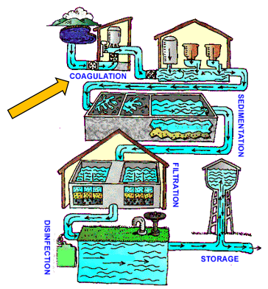
Image of water treatment by the EPA is in the public domain
After reading this chapter you should be able to identify and explain the following:
- Coagulant types
- Coagulation chemistry
- Mixing systems for both coagulation and flocculation
- Flocculation process theory
- Pounds formula

Coagulant Types
In general, two types of coagulants are used during coagulation. A primary coagulant and a coagulant aid will be used during the rapid mix process. The colloidal surfaces are negative thus positively charged metal salts are used as primary coagulants. The coagulant dissolves in water and ionizes. To ionize is when a molecule loses or gains an electron to form an ion. The three most common coagulants used in water treatment are Aluminum Sulfate (Alum), Ferric Sulfate, and Ferric Chloride. The most commonly used primary coagulant in water treatment is Alum because of its wide availability and affordability.
Synthetic polymers are often used as a coagulant and filter aid but have also been used as a primary coagulant. Operators use different charged groups of polymers known as cationic (positive), anionic (negative), and nonionic (without ionizable groups). Coagulation aids assist in the building of settable floc.
Important things to consider when choosing a polymer:
- Overdosing a polymer can decrease the efficiency of the coagulation process and cause filter binding and increased headloss in filters.
- Not all supply water is created equal. Every single water source has different chemistry and jar tests must be performed to see what polymer works best with the specific source water.
- There is no widespread standard for choosing a polymer. Different states have chemical approval standards that must be met.
- The addition of chlorine can effect polymer effectiveness.
- As with any chemical, there is a dosage limit.

Chemistry
Like many processes in water treatment, the theory of coagulation is very complex. As an operator you should have a basic understanding of the chemistry involved in each process. The coagulant added to the water will react with the alkalinity in the water to form insoluble floc. Insoluble is something that will not dissolve. If the floc is not formed properly, then operators cannot effectively remove pathogens from the treated water. Alkalinity is not the same as pH. This gets very confusing as “alkaline water” has become a more widely popularized marketing term. Alkalinity is the water’s ability to neutralize an acid based on its makeup of carbonate, bicarbonate, or hydroxide. The measure of alkalinity is the amount of acid that would have to be added to water to lower the pH to 4.5 and there is where the confusion arises.
Coagulation is most effective in the pH range of 5-7 because of the waters ability to react with alkalinity. In this range the water tends to buffer or stay in the same pH range and will allow the complete mixing of coagulant chemicals. If the raw water has a low pH, agents such as soda ash can be added to increase the pH.
Proper water quality tests must be performed by operators to promote the proper addition of coagulant chemicals. Under dosing coagulants will cause problems with floc formation while over dosing coagulants can cause clogging during the filter process. Clogged filters lead to head loss problems in the filters and increased filter washing.

Mixing
As noted earlier the coagulation process is completed within a matter of seconds. Mixing can be achieved by utilizing hydraulic mixers, mechanical mixing, diffusers, or pumped blenders. Hydraulic mixers use flow to achieve mixing. This kind of mixing requires enough flow to create a disturbance in the water to achieve proper mixing. Mechanical mixers require the greatest amount of energy because they require an electrical source to achieve mixing. Diffusers apply uniform flow during the coagulation process but may require many adjustments after flow changes. Finally, pumps can be used to push coagulant into water flow. Mixing can occur in a basin, channel or pipeline.

Flocculation
Flocculation is the slow mixing process that causes smaller particles to merge into larger particles that settle more easily. The particles are then more easily removed in the sedimentation and filtration process. The process of flocculation is achieved by controlling the rate of impacts between particles as they gain size. Floc size can range between .1 mm-3 mm. The size of the floc produced depends on which type of treatment process is utilized at a specific plant. It is important that floc has good size but also density so the floc will not shear during the sedimentation and filtration process. This process is much longer than coagulation lasting roughly 15-45 minutes.
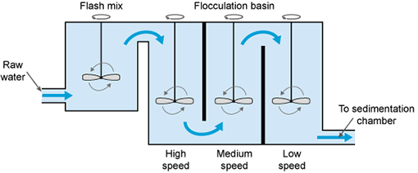
The coagulation–flocculation process by The Open University and partners is licensed under CC BY-NC-SA 4.0
Shown Above: The flash mix portion is also known as coagulation. The chemicals are added together and the process occurs within seconds. After flash mix, the water heads to the flocculation basins to allow floc particles to gather in size.
Mechanical flocculators can be installed both horizontally and vertically. The horizontal type utilizes paddle style mixers while the vertical style mixers can include paddle, turbine, and propeller style mixers. The shape and size of a flocculation basin is determined by the type of mixing used and the adjacent structures such as the sedimentation basins. Flocculation basins are usually split into 3 compartments. The speed of the mixing is decreased in each compartment to prevent the particles from breaking apart as they become larger. If the particles break apart during flocculation, the particles will place a heavier burden on the filters during the filtration process causing lower filter run times. This phenomenon will be discussed in further detail in chapter #6.

Monitoring and Process Control
The coagulation and flocculation process requires a great amount of attention to detail along the way. An operator cannot just set a dose and “hope” everything works out. Water quality can change frequently and operators must ensure they are on top of changing conditions. One way an operator can achieve this is through jar testing. This is a laboratory procedure that finds the best coagulant dose based on water quality conditions.
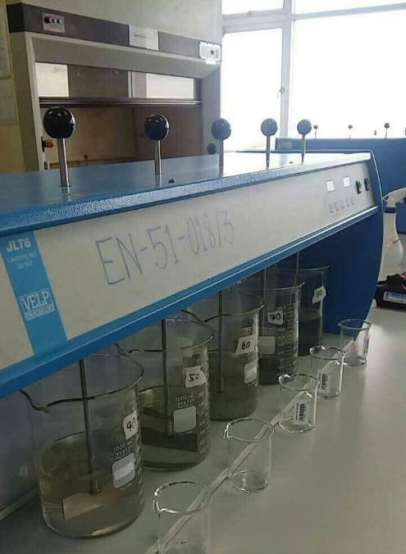
Image of a jar test by Jigchen L. Norbu is licensed under CC BY-SA 4.0
The efficiency of water treatment plants is determined by the combined effluent turbidity reading. Individual filter efficiency is also closely monitored. This will be discussed at length in the filtration chapter of the text, but it’s important to have a basic grasp of that concept at this point in the treatment process. Water treatment is a lengthy process. What’s occurring right now can have grave impacts down the line in the treatment process. Because of this consideration, jar testing and plant monitoring is all the more critical. Jar testing and laboratory grab sampling ensures the water which is theoretically being treated now, will be safe when entering the distribution system hours from now.
During abnormal conditions, it is important for operators to take notes and inform senior operators and/or a supervisor. Record keeping is important because operators can go back to notes used from previous experiences. For example, a large rain event has changed the influent turbidity entering the treatment plant. A similar event happened three years prior and the influent turbidity is very similar to the ones operators are seeing currently. Wouldn’t it be nice to have a record of what the operators did three years ago? Hopefully the operations staff from three years ago noted changes in coagulant dose, mixing speeds, chlorine demand, and other significant plant changes.

Enhanced Coagulation
The enhanced coagulation process is used to remove natural organic matter by adjusting the pH and coagulant dose to remove the greatest amount of suspended matter during the treatment process. The addition of acid is used to achieve the proper pH unlike sweep treatment were the operator overdoses the coagulant to achieve the correct pH range. Enhanced coagulation occurs at a lower pH. and accordingly will see improvements in treatment such as:
- Humic and fulvic molecules separate better with lower pH. Humic and fulvic acids are organic acids commonly found in raw water sources
- Less coagulant is required for treatment
- Flocculation improves at a lower pH
- Sulfuric Acid addition before coagulant is added preconditions organic matter

The Pounds Formula (Chemical Dosage Problems)
One of the most important calculations an operator will use is the “Pounds Formula.” The pounds formula can be used to solve water math problems including milligrams per liter to pounds per day, feed rate, chlorine dosage, percent strength, and dilution calculations. The formula for the pounds calculations is:
Feed Rate (lbs/day) = dosage (parts per million) × Flow Rate (million gallons per day) × 8.34 lbs/gal
Below is the pounds formula expressed in a mechanical wheel. The mechanical wheel can be used to solve a chemical dosage problem by plugging in the given information and then multiplying or dividing as indicated to determine the solution. For an example: A treatment plant will produce 2 MG a day. The chlorine dose is 3.0 mg/L. How many pounds of chlorine will the operator use?

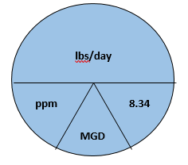 | 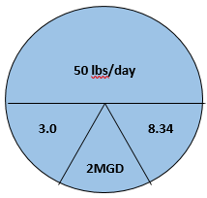
Feed Rate = 3.0 × 2 × 8.34
Feed Rate = 50 lbs/day
It is important to note that when using the pounds formula, the water production is always expressed in MGD. For example, a problem may ask what the chlorine production is for a water treatment plant that produces 1,000,000 gallons a day. This is the easiest expression because 1,000,000 ÷ 1,000,000 = 1.
EX: A water treatment operator must super chlorinate a 650,000 gallon tank at 50 ppm. How much chlorine must the operator add?
50 × .65 × 8.34= 271 pounds
* You must divide 650,000 by one million to get .65 to solve the equation. Round to the nearest tenth or hundredth place to get the most accurate answer. Remember you must show all work during exams to get credit but the format is still multiple choice so be careful when rounding.

Practice Pounds Formula Problems

Example 1
The dry alum dosage rate is 15 mg/L. The daily flow rate of a treatment plant is 5 MG. How many pounds of dry alum per day is required?
Feed Rate= 15 mg/L × 5 MGD × 8.34 lbs/gal
Feed Rate = 625.5 lbs/Day
* This sample problem is pretty simple. Plug the numbers into the equation and multiply to get your answer.

Example 2
A treatment plant uses 300 lbs of alum a day. The plant output is 2,500,000 gallons a day. What is the dose?
Step 1: 2,500,000 ÷ 1,000,000 = 2.5 MGD
$$\text{Dose=}\frac{\text{300 }\text{lbs}\text{/day}}{\text{2.5 × 8.34}} \text{Dose}=\frac{\text{250}}{\text{20.85}} \text{Dose}=12 \text{mg/L}$$

Example 3
How many pounds of 65 % available chlorine must an operator add to a treatment plant with a dose of 3.0 mg/L and a plant output of 5 MGD?
* Start the equation as you normally would. Since you are adding a solution of chlorine that is not 100 percent an extra step is needed to solve the problem. Remember, if the chlorine solution is not 100 percent available chlorine you are going to need more to dose properly!!!
Feed Rate= 3.0 × 5 × 8.34= 125 lbs/Day
Next you will need to make an adjustment based on chlorine strength
(.65)(× lbs/Day)= 125 lbs/Day
$$x=\frac{125}{.65}$$
x = 192 lbs/Day
Note: If the number is smaller than your original number you multiplied instead of dividing. You will always need more chemical if it’s not 100% strength.

Example 4
A water tank that is 30 ft high and 100 f in diameter must be dosed at 50 ppm for disinfection. How many pounds of 65% calcium hypochlorite must be added to dose the tank?
.785 × 100FT × 100FT × 30FT × 7.48 Gal/ft³ = 1,761,540 Gallons
1,761,540 Gallons/ 1,000,000= 1.76MGD
Feed Rate = 50 × 1.76 × 8.34= 733.92 pounds/Day
(.65)(x)= 734
$x=\frac{734}{.65}$ x = 1129 lbs

Chapter Review
- The optimal coagulant dose is determined by a
  - Chlorine Test
  - Flocculation test
  - Jar Test
  - Coagulation test

- The most common primary coagulant is
  - Alum
  - Cationic polymer
  - Fluoride
  - Anionic polymer

- Bacteria and Viruses belong to a particle size known as
  - Suspended
  - Dissolved
  - Strained
  - Colloidal

- The purpose of coagulation is to
  - Increase filter run times
  - Increase sludge
  - Increase particle size
  - Destabilize colloidal particles

- The purpose of flocculation
  - Destabilize colloidal particles
  - Increase particle size
  - Decrease sludge
  - Decrease filter run times

- Primary coagulant aids used in treatment process are
  - Poly-aluminum chloride
  - Aluminum sulfate
  - Ferric chloride
  - All of the Above

- Flocculation is used to enhance
  - Number of particle collisions to increase floc
  - Charge neutralization
  - Dispersion of chemicals in water
  - Settling speed of floc

- If there is a problem with floc formation, what would you consider changing?
  - Adjust coagulant dose
  - Stay the course
  - Adjust mixing intensity
  - Both A & C

- Which step in the treatment process is the shortest?
  - Filtration
  - Sedimentation
  - Flocculation
  - Coagulation

- To lower the pH for enhanced coagulation the operator will add
  - Chlorine
  - Sulfuric acid
  - Lime
  - Caustic Soda

- The flocculation process lasts how long?
  - Seconds
  - 5-10 minutes
  - 15-45 minutes
  - Over an hour

- The function of a flocculation basin is to
  - Settle colloidal particles
  - Destabilize colloidal particles
  - Mix chemicals
  - Allow suspended particles to grow

- A treatment plant has a maximum output of 30 MGD and doses ferric chloride at 75 mg/L. How many pounds of Ferric Chloride does the plant use in a day?
  - 18,765
  - 17,765
  - 19,765
  - 16,765

- A treatment plant uses 750 pounds of alum a day as it treats 15 MGD. What was the dose rate?
  - 4 mg/L
  - 5 mg/L
  - 6 mg/L
  - 7 mg/L

- A treatment plant operates at 1,500 gallons a minute and uses 500 pounds of alum a day. What is the alum dose?
  - 18 mg/L
  - 28 mg/L
  - 8 mg/L
  - 38 mg/L

Chapter 5 – Sedimentation
Sedimentation is the 3rd step in a conventional treatment process. It occurs after coagulation and flocculation and before filtration. Sedimentation removes suspended solids with the use of gravity by slowing the flow of water down to allow material to settle. The settleable solids fall to the bottom of the sedimentation basin reducing the load on the filtration process. A sedimentation basin acts like a lake in the sense that it allows particles to settle naturally. Deeper lakes have much higher quality water entering the treatment plant because the water is able to “settle” for a longer period of time. Treatment plants which use imported water from higher turbidity water sources may be required to use conventional treatment with sedimentation for efficient treatment.
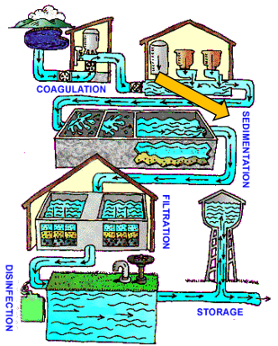
Image of water treatment by the EPA is in the public domain
After this chapter you should be able to identify and explain:
- Sedimentation process
- Zones of sedimentation basin
- Types of sedimentation basins
- Velocity Math problems
- Detention Time

Factors affecting Sedimentation
Several factors can affect the sedimentation process including physical and environmental conditions. Increased pretreatment may be necessary when adverse conditions are present. Factors that affect the sedimentation process include the shape and size of particles, the density of particles, water temperature, particle charge, dissolved substances in the water, environmental effects, and characteristics of the basin.
As discussed in the previous chapter, smaller particles do not settle out easily and their size must be increased with coagulation and flocculation. The larger, denser particles created are called floc. Particles greater than .01 millimeters will settle in the sedimentation process. The shape of particles is also a consideration. Smoother particles with less jagged edges settle out quicker and easier.
Temperature decreases will cause the settling rate to decrease. The settling rate or velocity decreases when the water temperature is colder. Chemical dosage rates need to be adjusted during colder periods of the year or lower flows are necessary in the flocculation basins.
There are three types of currents, surface, density, and eddy, found in a sedimentation basin. Surface currents are caused by wind while density currents are caused by temperature differences and the concentration of solids. Eddy currents are caused by the influent and effluent flow of water in the sedimentation basin. Currents can be beneficial as they can help to promote the building of floc, but they can also cause uneven disbursements of solids throughout a sedimentation basin reducing the efficiency.

Sedimentation Zones
The four zones of a Sedimentation basin include:
- Inlet Zone: where the water enters seamlessly from the flocculation basin. Water is distributed evenly throughout the sedimentation basin to prevent short circuiting. Short circuiting occurs when water entering a treatment process tank or basin quickly moves from influent to effluent reducing the waters detention time in a given process.
- Settling Zone: is the largest part of a sedimentation basin. The water will stay here undisturbed for three or more hours while particles settle to the bottom.
- Sludge Zone: located at the bottom of the settling zone. It is where settled particles collect in the form of sludge. Velocities at the bottom of the sludge zone should be minimized to prevent solids from re-suspending.
- Outlet Zone: the location where water seamlessly enters a channel or conduit. Launders also known as effluent troughs are used to collect the clarified or settled water.

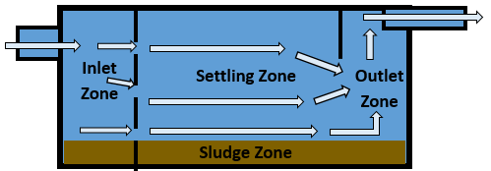
Image by COC OER is licensed under CC BY

Types of Sedimentation Basins
There are several different types of basin designs available for engineers and planners when building a water treatment facility. Rectangular basins are typically found at large scale water facilities because of their predictable treatment and high tolerance to turbidity, color, and algae. They are cost efficient, require lower maintenance, and have less short circuiting issues. The figure above representing the different zones of a sedimentation basin is an example of a rectangular sedimentation basin.
Circular and square basins are used in areas where space is limited. They are sometimes called clarifiers and are subject to short circuiting in the corners. The circular variety can also include up flow clarifiers or solids contact clarifiers. In these types of clarifiers the coagulation, flocculation, and sedimentation process all occur in the same basin or clarifier.
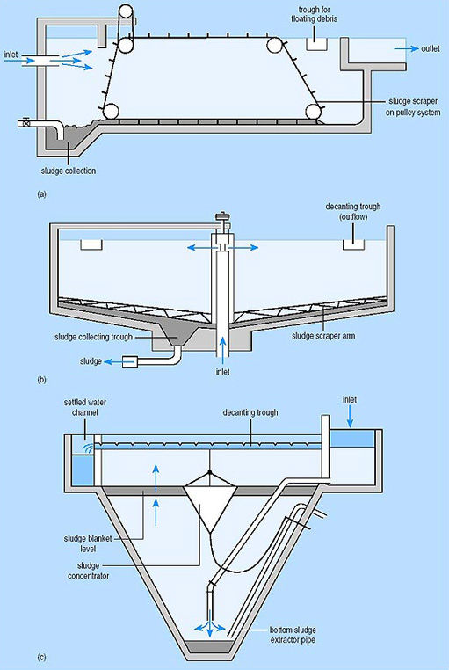
Typical sedimentation tanks: (a) rectangular horizontal flow tank; (b) circular, radial-flow tank; (c) hopper-bottomed, upward flow tank – Image by The Open University is licensed under CC BY-NC-SA

Detention Time
Detention time is the amount of time it takes water to travel through a tank or sedimentation basin. It is also referred to as retention time. You will hear some operators use the terms CT and contact time interchangeably but it is incorrect. The term CT will be discussed in greater detail in Chapter 7. Detention time can be used to solve equations for time and flow. Formulas for both types of equations are listed below:
Detention Time (Hours) = $\frac{Volume gal (24\frac{Hours}{Day})}{Flow gal/Day}$
Flow, gal/Day = $\frac{Volume (24\frac{Hours}{Day})}{Detention Time, Hours}$
Reminder: Circular volume calculation (.785)(D ft.)²(Depth ft.)
Rectangular Volume calculation: (L ft.)(W ft.)(D ft.)
Answers will be in cubic feet so it will be multiplied by 7.48 gal/ft³ to convert to gallons

Example 1
A rectangular sedimentation basin is 80 ft. long by 25 ft. wide and is 25 ft. deep. The flow per day is 2.0 MGD. What is the detention time in hours?
Step One: calculate the volume of the basin (80 ft.)(25 ft.)(25 ft.)(7.48 gal/ cubic ft.)= 374,000 gallons
Step two: DT= $\frac{374,000 gal X 24 Hours}{2,000,000 gal day}$
Step Three: Detention Time = 4.5 hours
*Note: more complicated problems will have you solve for hours and minutes. Keep this in mind for future math equations that ask for more information.
$$\frac{.5 hours}{1}×\frac{60 min}{1 Hour}=30 min$$

Example 2
A circular basin is 100 ft. in diameter. The basin is 25 ft. deep and has a detention time of 4 hours. What is the flow per day?
Step one: calculate volume .785(100 ft)²(25 ft)(7.48 gal/ cubic ft.)= 1,467,950 gal
Step Two: Flow= $\frac{1,467,950 gal X 24 Hours}{4 hours}$
Step three: Answer is 8,807,700 divide by 1,000,000 to get 8.807 or 8.8 MGD

Sludge handling and removal
Sludge that collects at the bottom of a sedimentation basin must be removed from time to time for several reasons. As discussed earlier in the chapter, sludge can become re-suspended after settling creating greater load on the downstream filter. Next, sludge buildup can cause the water source to become septic. In this scenario, microbiological growth occurs when oxygen supplies are depleted. Septic conditions can cause taste and odor problems in treated water and also require more chlorine during the disinfection process. Finally, the more sludge that builds up leads to decreased detention time because there is less area for the water to travel and for solids to settle out.
Larger plants will have to remove sludge at a greater rate and with the assistance of sludge removal equipment. Smaller plants may be able to remove sludge manually with portable sanitary pumps and squeegees and hoses to complete cleanup. The amount of time between cleanups can vary with the quality of the water source and the amount of water being treated. Consequently, shutdowns for sludge clean-up will vary dramatically from treatment plant to treatment plant.
Sludge removal equipment includes mechanical rakes, drag-chain and flights, and traveling bridges. The chain and flight system is used in rectangular basins. A chain with scrappers attached moves across the bottom of the basin collecting sludge and moving it to a sump. This system works well but has several moving parts. Additionally, the basin must be dewatered to perform maintenance. The traveling bridge system is also used in a rectangular basin. It travels the entire length of the basin. A pump is attached to the bottom of the system and sludge is pumped to a trough just below the top of the sedimentation basin. The bridge system is easier to perform maintenance on because the parts can be removed from the basin; therefore, dewatering the entire basin isn’t required. Finally, mechanical rakes are used in rectangular or circular basins. A rake spans the entire length of the basin while spinning around the basin. Sludge is moved into a trough which can be pumped out or moved by gravity to a sludge collection tank.
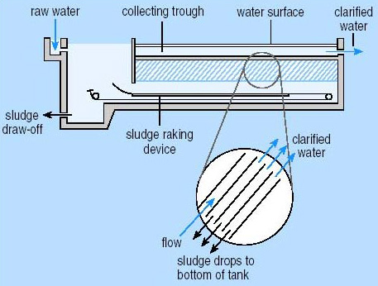 | 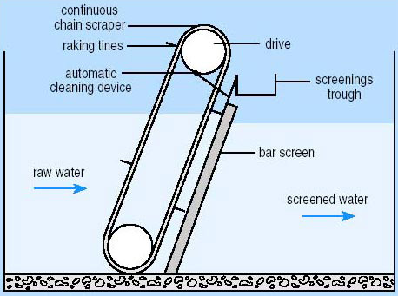
Image by The Open University is licensed under CC BY-NC-SA | Image by The Open University is licensed under CC BY-NC-SA

Review and Daily Operations of Sedimentation Basins
In review, the purpose of sedimentation is to allow suspended solids to settle through the physical process of gravity. The flow of water is slowed down to allow settling to occur. During the process, sedimentation can remove 95% or more of the total solid material operators remove during the entire water treatment process.
Water treatment plants with low turbidity or fewer than 10 turbidity units may find direct filtration or clarification to be a more cost effective process. A reoccurring theme that should be noted throughout the text is the fact that all treatment facilities are different and the factor that dictates plant processes including facility building and day to day operation is the source water.
The settling characteristics of suspended material dictates how well sedimentation performs. Flow rate through the sedimentation basin drives performance as well as the control of sludge. High flow rates cause solids to carry over, and could also impact the sludge at the bottom of the sedimentation basin. Operators must perform regular jar testing and laboratory testing as well as operate sedimentation basins based on the designed capacity of the basin to ensure optimal performance. Improper operation of sedimentation basins will lead to increased load on downstream filters resulting in early filter washes, increased disinfectant use, and possibly tier violations.

Velocity Math
The movement of water is obviously an important thing to know if you are a water treatment operator. You will need Algebra to solve the next set of water math problems which will have two known values and one unknown value. Flow rates can be used to determine dosage rates, to identify daily averages, to dewater pipelines, to fill pipelines, and for future planning of distribution and treatment equipment.
To solve a flow problem, you need the diameter of the pipe and the velocity of the water (or liquid) in the pipe. Flow rate is expressed as Volume over Time. The equation will be Q(Flow) = A(area) × V(velocity). A velocity problem occurs when the known value is the pipe diameter and flow rate of pipe. V(Velocity) = Q(Flow) ÷ A(Area). Finally, pipe size is used when known value is pipe flow rate and velocity. A(Area) = Q(Flow) ÷ V(Velocity).
Proper use of dimensional analysis is critical when attempting to solve velocity equations. These types of problems often take multiple steps because answers need to be converted to the appropriate units based on the situation.

Example 1
A pipeline is 18” in diameter and flowing at a velocity of 125 ft. per minute. What is the flow in gallons per minute?
Step one: convert pipeline diameter to feet. $\frac{18 \text{inches}}{12 \text{inches}/\text{foot}}=1.5 \text{ft.}$Step Two: Q(Flow) = (.785)(1.5ft.)²(125 ft./min)
Step Three: 221 ft³ per minute × 7.48 gal/ft³ = 1651 gpm

Example 2
The flow of a pipe is 2,000 gallons per minute. The diameter of pipe is 24”. What is the velocity of the pipe in ft. per minute?
Step one: Convert units 2,000 gpm ÷ 7.48 gal./ft³ = 267 ft³/min. 24 inches ÷ 12 inches/ft = 2 feet
Step two: V(velocity) = 267 ft³/min ÷ .785(2 ft.)²
Step three: V = 85 feet per minute

Example 3
The velocity in a pipeline is 2 ft./sec. and the flow is 3,000 gpm. What is the diameter of the pipe in inches?
Step One: convert flow to match units of measurement of velocity. $$\frac{3,000 \text{gal}}{\text{min.}}×\frac{1 \text{min}}{60 \text{sec}}×\frac{1 \text{ft³}}{7.48 \text{gal}}=6.68 \text{ft³}/\text{sec}$$
Step two: Area= 6.68 ft³/sec ÷ 2 ft./sec= 3.3 feet
Step three: convert feet to inches $\frac{3.3 \text{feet}}{1} × \frac{12 \text{inches}}{1 \text{feet}}$ = 40 inches

Chapter Review
- The treatment process that involves coagulation, flocculation, sedimentation, and filtration is known as
  - Direct filtration
  - Slow sand Filtration
  - Conventional treatment
  - Pressure filtration

- Sedimentation produces waste known as
  - Backwash water
  - Sludge
  - Waste water
  - Mud

- What kind of process is the sedimentation step?
  - Physical
  - Chemical
  - Biological
  - Direct

- The weirs at the effluent of a sedimentation basin are also called
  - Effluent weirs
  - Baffling
  - Launders
  - Spokes

- Sedimentation is used in water treatment plants to
  - Settle pathogenic material
  - Destabilize particles
  - Disinfect water
  - Reduce loading on Filters

- Scouring is a term that describes conditions in a sedimentation tank which
  - Could impact the rest of treatment process
  - Higher flow rates in the sludge zone
  - Re-suspends settle sludge
  - All of the above

- The four zones in a Sedimentation basin include
  - Inlet, sedimentation, sludge, outlet
  - Inlet, filter, waste, outlet
  - Inlet, top, bottom, outlet
  - Surface, sedimentation, sludge, outlet

- 8. Short circuiting in a sedimentation basin could be caused by
  - Surface wind
  - Ineffective weir placement, or weirs covered in algae
  - Poor baffling in sedimentation inlet zone
  - All of the Above

- 9. How much solids should be removed during sedimentation?
  - 95% or more
  - 80-95%
  - 70-80%
  - 60-70%

- The type of basin that includes coagulation and flocculation is
  - Rectangular
  - Triangular
  - Up-Flow
  - None of the above

Chapter 6 – Filtration
Filtration is the final and most important removal requirement required by the Surface Water Treatment Rule (SWTR). Water passes through material such as sand, gravel, and anthracite coal to remove floc and disease causing microorganisms from the finished water. Physical removal of colloids is also achieved during sedimentation but this filtration is the final step. This is the process where suspended colloidal particles are removed from the water. Along with removing possible pathogenic material in the water, removal of turbidity is also achieved which could hide pathogenic organisms and add color to the finished water.
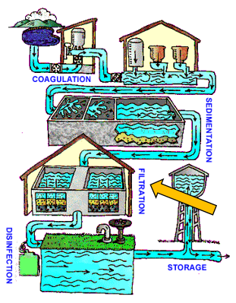
Image of water treatment by the EPA is in the public domain
After reading this chapter you should be able to identify and explain the following:
- Treatment Technologies
- Filter media configurations and Types
- Filter Operation and Backwashing
- Filtration Math
The SWTR sets forth guidelines for all public water agencies that use surface water as a source. Surface water was covered in chapter #1 and is any water open to atmosphere that is susceptible to runoff. The minimum requirements for treatment is disinfection, but most water sources do not meet these very stringent guidelines.
The effectiveness of filtration is based on several important factors. Proper filtration occurs based on incoming source water quality. For example a storm event near the source water could case higher incoming turbidity than the treatment plant is used to handling. Operational changes such as washing filters may be required. The physical and chemical characteristics of suspended material also come into play during treatment. Too much or too little chemical can lead to ineffective filtration. To follow the storm event example an operator may need to make changes to coagulant and polymer doses to account for increased turbidity and particulate entering the treatment plant. Finally the type of filtration used by a treatment facility is also very important. This decision is mostly out of operators hands as engineers and water quality experts will decide what the most effective treatment process is for the source water before building a treatment facility.
Pictured below is a filter in normal operation.
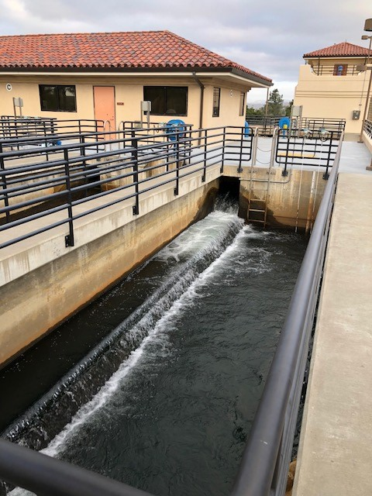

Treatment Technologies
There are four approved treatment technologies in the United States. The most widely used treatment technologies include conventional treatment, direct filtration, diatomaceous earth treatment, and slow sand filtration. Below are the descriptions:
Slow sand filtration facilities are becoming less common because of the large amount of time it takes to treat water and the large amount of space the facilities require. The filtration rates for slow sand filtration are .05 to .10 GPM/sq ft. Particles are adsorbed in a chemical layer known as a schmutzdeke. After an amount of time the biological layer must be manually removed by an operator or maintenance staff. The slow time and intensive labor make this treatment method the least ideal especially in areas with larger populations.
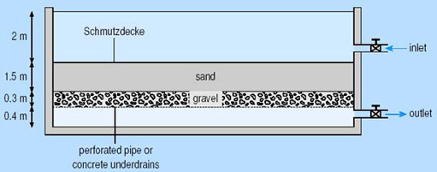
Image by The Open University is licensed under CC BY-NC-SA
Diatomaceous Earth filtration is accomplished through pressure filtration. It can also be referred to as precoat filtration. The filter media in this case is added as slurry to the treatment vessel. Within the vessel lays a pipe known as a septum. The slurry attaches itself to the septum and water is run through the vessel where pathogenic and suspended material is captured and strained out of the finished water. This kind of treatment process is very common for swimming pool treatment and beverage companies. This type of treatment method is generally not used by larger municipalities because of the large amount of disposal of sludge and the continuous purchasing of filter media.
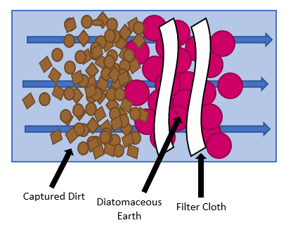
Image by COC OER is licensed under CC BY
Gravity filtration is comprised of the final two approved Water Treatment technologies. Direct Filtration and conventional treatment are the most widely used treatment technologies in the United States. It is described as gravity filtration because the head pressure of the water forces the water to travel through filtered media in order to remove impurities from the drinking water. Direct Filtration differs from conventional treatment because the sedimentation process is skipped. Areas with source water higher in quality may opt for direct filtration to reduce costs and the amount of land space for sedimentation basins can be substantial. The average filtration rate for gravity filtration beds is 3.0 GPM/Sq. ft.- 6.0 GPM/ sq. ft.
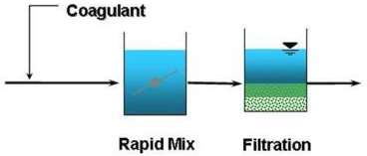
Direct Filtration - Image by the EPA is in the public domain
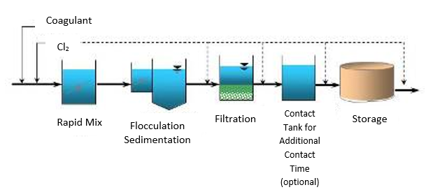
Conventional Treatment - Image by the EPA is in the public domain
Alternative treatment plant methods can be approved on a case by case basis. Newer technologies such as membrane filtration and reverse osmosis have been utilized as the technology has improved and the costs associated with running these particular operations have decreased. Santa Clarita Valley (SCV) Water utilizes an alternative technology known as Upflow Clarification. SCV Water is able to use this technology because of the very low turbidity levels in the water provided by Castaic Lake. It is a more condensed version of conventional treatment and requires much less space due to the lack of sedimentation basins.

Filter media
The type of media used in gravity filters is sand, anthracite coal and garnet. Garnet is a reddish colored mineral sand comprised of silicates (calcium, iron, manganese, and magnesium) and its density is greater than sand. Gravel is also used as a filter under layer below the filter media being used. It has to be heavier than the filter media so it is able to settle back under media after a completed filter wash cycle.
When choosing filter media it is important to select media which has good hydraulic characteristics, is durable, has no impurities, is insoluble in water, will not dissolve, and does not react with constituents in the water supply. Media is classified by four parameters including its effective size, uniform efficiency, specific gravity, and the hardness of the media. The effective size is the sieve opening in the media that allows water to pass through while collecting the impurities in water. 90 percent of the particles must be bigger than the opening to filter out particles.
When deciding what kind of media to choose for the filer it is important to consider the amount of time it takes for filter turbidity to break through. For example, you operate a treatment plant that requires individual filters say below 0.3 NTU (or Nephelometric Turbidity Units). Once an individual filter goes above this limit it must be washed. Secondly, head loss must be a consideration. Head loss occurs after material builds up over time during the filtration process. The head loss will cause longer filtration times and cause the filter level to rise. Once a filter reaches terminal head loss it must be back washed. The media is not always the cause of head loss and turbidity break through. As discussed earlier, operators must ensure they are dosing chemicals properly as improper dosage can cause the aforementioned head loss and breakthrough.
The uniform coefficient is the ratio between the different sizes of media comprised in the filter bed. The lower the uniform coefficient means the media is closer to the same size than if it were higher. The lower the efficiency number adds to the cost of the media.
Filter production is the amount of water that a given filter can produce in a day. This flow is usually accounted for in Million Gallons per Day (MGD). Individual filtration rates are calculated by dividing the flow rate of the filter in gallons per minute by the surface area of a filter. The filtration rate for gravity filters can be between 2gpm-10gpm/ square foot. This topic will be discussed in more detail during the math portion of this chapter.
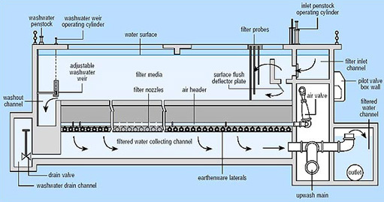
Rapid gravity sand filter - Image by The Open University is licensed under CC BY-NC-SA
Filter Media Types
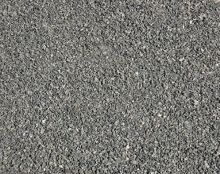 |  | 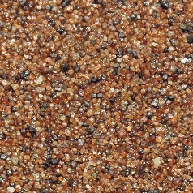 | 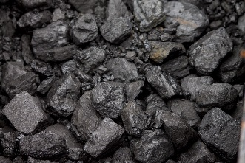
Gravel  Image by Martin Olsson is licensed under CC BY-SA 3.0 | Sand  Image by Yug is in the public domain | Garnet  Image by Siim is licensed under CC BY-SA 4.0 | Anthracite  Image is in the public domain

There are several different types of media configurations. Filtration plants can utilize monomedia, duel media, and multimedia configurations. A monomedia plant has only one type of media which could be course sand or anthracite coal. Single media filters may have to be washed more frequently as they tend to be smaller and have more frequent head loss issues. Duel media filters consist of a lower sand level and an upper anthracite layer with larger diameter pores that allow deeper solids penetration. Finally, multimedia filters are used in pressure vessel treatment applications. Multimedia filters have sand, anthracite, and an upper garnet layer. The drawback to pressure vessels is the inability to view filter media within the pressure vessel.

Filter Operation and Backwashing Filters
Throughout the chapter the subject of “washing” has come up. Filter run times are dependent on three factors but first it is important to know how filter efficiency is measured. The efficiency of a filter is measured by the filter effluent turbidity. And the overall plant efficiency measures the combined effluent turbidity of all the filters. Improper coagulation and filtration could lead to turbidity spikes and in the worst case scenario could lead to a public health crisis.

Pictured below is a photo of a typical filter deck at a water treatment plant.
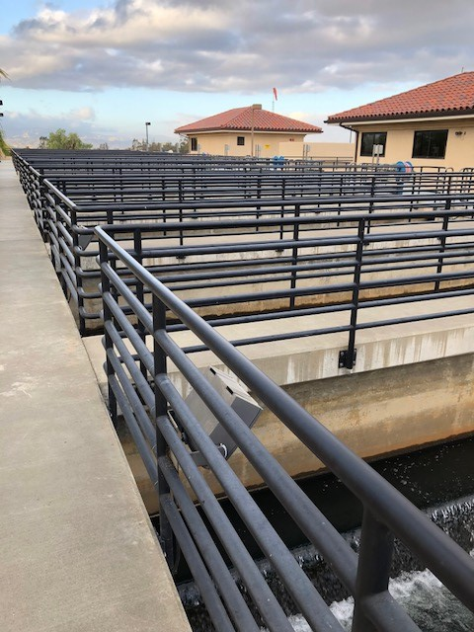
The first factor that an operator uses to determine whether a filter wash is necessary is the individual filter turbidity. Each treatment plant will have its own operating conditions and permits to follow. If an individual filter fails to meet the turbidity goals or limits, the filter must be put in a backwash cycle. Filters that continue to have decreased run times may need a filter profile ran to figure out why the filters are not meeting standards.
High head loss is the second factor that will lead to a filter wash. After the filter is used for a certain period of time it becomes clogged with the solids the filter is removing. This condition will also lead to increased turbidity as the solids that should be getting captured “breakthrough” the effluent into the treated water supply. Finally, a filter wash will be performed after a certain period of time no matter what the operating conditions are. This is the ideal scenario for washing a filter.
The backwash procedure is the reverse flow of water through the filter. This process removes solids from the filter after breakthrough or the filter run time is hit. Operators must operate the backwash rates at an optimal range because inadequate rates will not properly remove the solids from the filter and excessive rates can cause mud balls and mounds to form within the filter.
Washed water is able to be recycled by sending the waste stream to collection basins. The water can then be returned to the head works of the plant and be mixed with raw water to be treated again. The filter backwash rule limits the amount of water that can be returned into the head works of the plant at a given time. Returning too much recycled water could increase the chances of allowing microorganisms such as Cryptosporidium into the treatment plant.
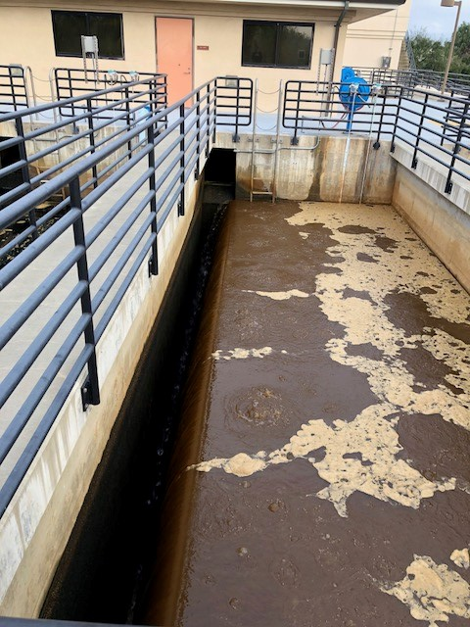
The Filter to the left is in the process of a filter back wash. The water is moving in the opposite direction and overflowing over the weir and heads to the waste basin where it is collected and eventually returned into the head works of the plant to be treated again. Operator Actions
As a Water Treatment operator you will be expected to have knowledge of how to properly use equipment related to filtration. While running a treatment plant you will routinely:
- Monitor filter performance
- Check turbidity levels with online analyzers and grab samples
- Adjust chemical flow rates
- Backwash filters
- Visually inspect filters
Filters run differently under changing water conditions. The plant will not always run the same as temperature differences and storm events will make operators examine important operational considerations from time to time. It is important to look at the weather and understand how it might affect the treatment plant. A severe rain storm near your source water could increase turbidity levels coming into the plant. Under these conditions operators may have to wash filters more frequently and make adjustments to chemical doses.
There are other abnormal conditions to consider when monitoring filter performance. Monitor filter washes to look for mud balls, excessive boiling in certain spots, and media being displaced and sent to waste basins. These conditions would indicate that the backwash flow is too high. Also identify shorter filter run times, filters that may not be coming clean, and algae growth. These factors may be due to improper chemical dosing and a back wash flow that is too low.

Filtration Math

Filtration Rate
Calculating the filtration rate of the filters in your plant is an important function. Operating plans and permits limit the amount of water a filter can produce so it is important to have an understanding of filter rates also known as loading rates. Filtration rates will also give an operator a basic understanding of the treatment plants daily average production.
The filtration rate formula is a velocity equation. These formulas are easily confused with flow problems so make sure you pay attention to the units you add into the formula and pay attention to what the problem is asking. The formula for filtration rate is:
Filtration Rate = Flow Rate ÷ Area
Filtration rate equations will use GPM and the area of a given filter. The area of the filter is length x width. A problem may give you the depth of a filter to confuse you. Pay very close attention to the wording in the problem.

Example 1
What is the filtration rate of a treatment plant that has 3 filters that are 20 ft. wide and 20 ft. in length in a plant that produces 1 MGD?
Filtration Rate= (20 ft. x 20 ft. x 3) ÷ 1 MGD
$\frac{1,000,000 \text{gal}}{1 \text{Day}}×\frac{1 \text{D}\text{a}\text{y}}{24 \text{hours}}×\frac{24 \text{hour}}{60 \text{min}}=\frac{694 \text{GPM}}{1}$
*Note: quick shortcut for future equations, there are 1,440 minutes in a day
Filtration Rate = 1,200 ft.² ÷ 694 GPM
Filtration Rate = 1.73 gpm/ft ²

Backwash Rate
As discussed in the chapter, after a filter reaches its capacity due to head loss, turbidity break through, or maximum amount of hours run, the filter must be washed. The filter wash cycle water velocity will be much greater than the amount of water that flows through the filter during normal operation. Many math equations will have the operator solve for rate of rise which is expressed as in/min. The backwash is the flow of water in the opposite direction where water is moving up instead of down.

Example 2
The maximum back wash rate for a filter is 5,000 GPM. The filter is 20 ft. wide and 20 ft in length. What is the rate of rise in the filter?
Rise Rate = Flow Rate ÷ Area
Rise Rate = 5,000 GPM ÷ 400 ft.²
Rise Rate = 12.5 GPM/ sq./ft.
$$\frac{12.5\frac{\text{gal}}{\text{min}}\text{ft}}{1}×\frac{12 \text{inches}}{1 \text{ft.}}×\frac{1 \text{ft}³}{7.48 \text{gal}}=20 \text{inches rise}/\text{min}$$

Percent Back Wash
Water treatment plants are very efficient at recycling waste stream water. The water sent to waste basins and lagoons is able to be recycled but only a certain amount at a time. The percent backwash math problems compare the total plant production with the amount of finished water used to backwash a filter.

Example 3
A treatment plant treats 2 MGD. It has 2 filters that are washed each day and each uses 10,000 gallons during the wash. What is the percent back wash water?
2 filters x 10,000 gallons = 20,000 gallons
$$\frac{20,000 \text{gal}}{2,000,000 \text{gal}}=0.01$$
100 × 0.01 = 1%
1% of the water the plant uses is for backwash water

Chapter Review
- Solids removed from a filter are most commonly removed by what method?
  - Adsorption
  - Straining
  - Deactivation
  - Flocculation

- What is a typical filtration rate for slow sand filters?
  - 2.0-6.0 GPM/sq. ft.
  - 6.0-10.0 GPM/sq. ft.
  - 1.0-2.0 GPM/sq. ft.
  - 0.5-0.10 GPM/sq. ft.

- In a typical conventional treatment plant, the finished water turbidity for an individual filter should be less than
  - 1.0 NTUs
  - 0.3 NTUs
  - 5.0 NTUs
  - 3.0 NTUs

- A filter running under normal conditions will see head loss in a filter
  - Remain constant
  - Increase slowly
  - Rapidly increase
  - Decrease slowly

- A filter must be washed if this condition is met
  - Head Loss
  - Turbidity break through
  - Maximum Filter run time
  - All of the Above

- Filter performance is measured by the removal of
  - Oxygen
  - Head loss
  - Turbidity
  - Chlorine

- What is the biologically active layer of a slow sand filter called?
  - Mixed Media
  - Duel Media
  - Sludge Layer
  - Schmutzdecke

- The pressure drop in a filter is called
  - Turbidity breakthrough
  - Head Loss
  - Filtration
  - Backwash

- What is the most common reason for putting a filter into the wash cycle?
  - Head loss
  - Filter run time
  - Turbidity breakthrough
  - Water level decrease

- Formation of mud balls and excessive boiling during a wash is an indicator of
  - Proper backwash rate
  - Too low backwash rate
  - Excessive backwash rate
  - Improper chemical dose

- Important processes which occur during filtration are
  - Sedimentation
  - Adsorption
  - Straining
  - All of the Above

- Typical filtration rates for a conventional treatment plant are
  - 0.2-0.6 GPM/sq.ft.
  - 2.0-10.0 GPM/sq.ft.
  - 10.0-20.0 GPM/sq.ft.
  - 200-400 GPM/sq.ft.

- There are four filters at a water treatment plant. The filters measure 20 feet wide by 30 feet in length. What is the filtration rate if the plant processes 8.0 MGD?
  - 1.51 GPM/sq.ft.
  - 2.31 GPM/sq.ft.
  - 2.61 GPM/sq.ft.
  - 2.91 GPM/sq.ft.

- A water treatment plant treats 6.0 MGD with four filters. The filters use 60,000 gallons per wash. What is the percent backwash at the plant?
  - 10 %
  - 8 %
  - 6%
  - 4%

- A treatment plant filter washes at a rate of 10,000 GPM. The filter measures 18ft. wide by 24ft. long. What is the rate of rise expressed in inches per minute?
  - 17 inch/min
  - 27 inch/min
  - 37 inch/min
  - 47 inch/min

Chapter 7 – Disinfection
The final step in the water treatment process before finished or treated water enters a clearwell for storage is the disinfection process. Disinfection is the process where chemical agents are added to a water source to kill or inactivate pathogenic microorganisms. Pathogenic microorganisms are disease causing and must be eliminated from treated water. As population sizes increase and fresh water sources become scarcer, the ability to remove and deactivate microorganisms becomes increasingly important. Another factor to consider, especially in California, is stricter regulations due to advancements in technology and water quality testing.
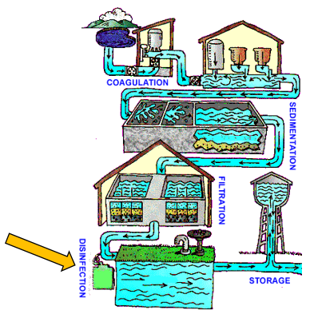
Image of water treatment by the EPA is in the public domain
After reading this chapter you should be able to identify and explain the following:
- Disinfection terminology
- Regulations
- Types of disinfectants used during water Treatment

Disinfection Basics
Treatment plant operators use the two-part process of removal and deactivation of microbiological constituents in water. Most of the pathogens water treatment professionals remove and deactivate from drinking water have adapted to living in the bodies of warm blooded animals. Pathogens thrive and survive in those environments. Outside those environments, these pathogens can stay dormant until they are consumed. Even more frightening, some of the illnesses can cause death. In the United States, our water is generally safe to drink and we often take for granted that turning on a tap will produce a flow of potable water.
Because of limitations in testing, it is difficult to indicate the presence of specific waterborne illnesses caused by virus, bacteria, and Giardia. Water professionals use tests such as the total coliform test to look for the likely presence of waterborne disease. The Surface Water Treatment Rule sets specific guidelines for removal and treatment to ensure the removal and inactivation of pathogenic organisms.
Strict regulations set forth by the Safe Drinking Water Act were created to ensure the public’s drinking water was safe to consume. To ensure drinking water is safe for human consumption, 3 log removal and deactivation or 99.9% of Giardia lamblia is required. For viruses, 4 log or 99.99% removal and deactivation is required. Bacteria fall in the middle of viruses and Giardia so the government determined it was not necessary to have regulations specifically regulating their inactivation and removal.
Below is a list of waterborne diseases and illnesses.
Table 7.1: Waterborne Diseases and Illnesses
Bacteria | Internal Parasite from Protozoa | Virus caused
- Anthrax  - Dysentery  - Cholera  - Gastroenteritis (Stomach Flu)  - Leptospirosis  - Paratyphoid  - Salmonella  - Shigellosis (Shigella)  - Typhoid fever | - Dysentery  - Ascariasis (round worm)  - Cryptosporidiosis from Cryptosporidium  - Giardiasis from Giardia | - Gastroenteritis  - Heart anomalies  - Hepatitis A  - Meningitis  - Poliomyelitis

Purpose of Disinfection
Operators disinfect water to destroy the harmful organisms listed in the above chart. Filtration is used to remove the organisms while disinfection kills them or deactivates them. Operators do not sterilize water because sterilization would kill everything in the water. The process of disinfection relies heavily on everything that occurs downstream in the treatment process. As water enters the treatment plant in the form of raw water, the chemistry of that water affects how well the specific disinfectant will work at each stage of the treatment process.

What effects disinfection?
There are several characteristics of water that can effect treatment. Water is more easily disinfected with higher temperatures. In lower temperatures, longer contact times may be required and larger amounts of chemical must be used. Higher turbidity rates will decrease disinfection as well. The chapters before have covered how critical it is to remove suspended material early and efficiently. Excess turbidity will require greater amounts of chemical to properly disinfect the water supply. Chemicals such as chlorine can interact with organic and inorganic matter. Chlorines ability to interact with these constituents may reduce or eliminate the effectiveness of the disinfectants.

Types of Disinfectants Physical
Physical disinfection is not widely used to treat potable water at this time. Ultraviolet rays are starting to be used more consistently but chemical means of disinfection must still be used as ultraviolet disinfection does not carry a disinfectant residual. The process is very expensive and thus is not used by large scale treatment operations in the United States. Other means of physical disinfection include boiling and ultrasonic wave production. Agencies will call for boil water notifications during emergencies and when there is a waterborne illness outbreak but it is not used as a primary means to disinfect drinking water.
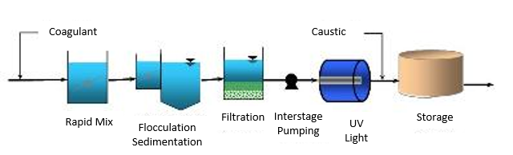

Image by the EPA is in the public domain

Types of Disinfectants Chemical
There are several chemical disinfectants available in drinking water applications. The most commonly used in the United States is Chlorine. The topic of Chlorine will be discussed in greater detail in the following chapter. The basics will be covered below as well as a background on the other chemicals available. The chemicals will be broken down into sub categories based on their practical usage in the United States.

Rare
- Iodine - It is commonly used for emergency treatment in the form of droplets or tablets. It is not used by the water treatment industry because of its cost and the potential health hazards to pregnant women and possible thyroid issues, which can develop with frequent use.
- Bromine - It is not used by water treatment facilities as it is very corrosive and can cause severe skin burns. It is used more commonly as a disinfectant in swimming pools. When it reacts with choline (a common nutrient from plants and animals) in water, it can create disinfectant byproducts. It was used by the United States Navy for a time, but most systems have been removed because of bromine’s corrosiveness.
- Sodium Hydroxide and Lime - more frequently used to sterilize pipes. They are not used as an everyday disinfectant because of the bitter taste that is left behind after application. Sodium hydroxide and lime are more often used to increase the ph of the water in the distribution system after treatment with gas chlorine.

More Common
- Chlorine Dioxide - used as a water treatment disinfectant and oxidizer. It does not react with ammonia which is an issue with chlorine. Chlorine dioxide is used as a disinfectant but is also very effective at removing iron, manganese, taste, odor, and color from treated water. Cryptosporidium is resistant to chlorine but is not resistant to chlorine dioxide. Up to 70 percent of chlorine dioxide is converted to chlorite, which is a regulated disinfectant by-product so the dosage rates when using it as a disinfectant must be lower than 1.4 mg/L. Chlorine dioxide must also be made on site which necessitates higher operational and maintenance costs.
- Ozone - Ozone was first used in Europe in the early 1900’s. It is a strong disinfectant that also reduces taste and odor issues. The drawback of ozone is that it is very expensive to produce, has high electrical costs, has limited solubility, and does not leave a residual in the treated water because it is so reactive. If bromide is present in the water, ozone can react with it to form bromate, an undesirable DBP (this is an issue for SCV Water). Ozone is very efficient at disinfecting Cryptosporidium so it is generally used as a secondary disinfectant along with chlorine or chloramines.

Most Common
- Chlorine - The most widely used disinfectant in the United States is free chlorine. Chlorine can be added as a gas in the form of chlorine gas, as a solid in the form of calcium hypochlorite, or as a liquid in the form of sodium hypochlorite. Most likely, you have a bottle of sodium hypochlorite in your house. We call it bleach. The use of free available chlorine has declined over the years because of the discovery of disinfectant by products (DBPs). This topic will be discussed in further detail in the next chapter.
- Chloramines - The use of chloramines has become more common in recent years in order to reduce DBPs mainly trihalomethane (THM). Chloramines are also referred to as combined chlorine as it is the combination of chlorine and ammonia. Chloramines are also effective at eliminating taste and odor problems and the residual lasts longer in the distribution system. However, chloramine disinfection is not as strong as chlorine and the improper addition of ammonia can lead to excessive amounts of ammonia in the treated water which results in nitrification.
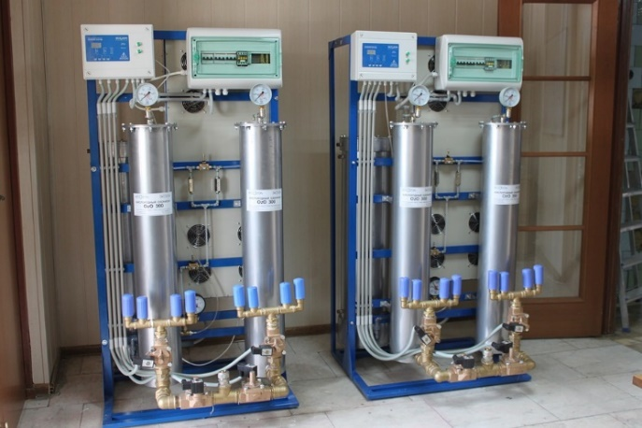
Image by olegschedrin0 is licensed under CC0

Regulations
The Safe Drinking Water Act (SDWA) is the basis of all drinking water regulations in the United States. It is the umbrella in which all new regulations and rules have subsequently been created and enacted. The SDWA regulates drinking water standards in the United States along with its territories. We take for granted all of the research and technology we have available that allows us to never really be concerned about the quality of our drinking water. The SDWA was passed in 1974 and set fourth standards to regulate public water sources. It was amended in 1986 to include some basic principle definitions:
- Defined regulated contaminants and approved treatment techniques
- Defined criteria for filtration of drinking water
- Defined criteria for disinfecting surface and groundwater
- Outlawed the use of lead material in drinking water facilities.
After a large public health crisis in Milwaukee, Wisconsin, provisions were made to support drinking water programs through operator training and certification programs. All entities serving water to the public were required to meet program standards with regards to training and certification. In 1999 the government allowed states to hold primacy over drinking water certification programs as long as federal minimums were met. States such as California often have stricter standards than the federal standards.

Surface Water Treatment Rule
The Surface Water Treatment Rule (SWTR) was enacted in 1990 and sought to prevent waterborne illness from surface water sources. Water systems with supplies from surface sources which are susceptible to carrying viruses, legionella, and Giardia lamblia, have to follow new requirements with regards to filtration and disinfection known as the multiple barrier approach. The rule also required that systems that used groundwater as a source for drinking water had to adhere to SWTR standards if their water source could come into contact with surface water sources.
Water treatment plants would have to achieve removal and deactivation requirements through the combined efforts of filtration and disinfection. The removal and deactivation of 99.9% of Giardia or 3 Logs and the removal and deactivation of 99.99% of viruses or 4 Logs was the new standard set forth. This requirement is measured by monitoring combined effluent turbidities in the combined filters and meeting disinfection requirements through the CT calculation. The CT calculation will be covered in greater detail in the following chapter.

Groundwater Rule
The Groundwater Rule (GWR) was established in 2009 in response to the frequency of groundwater contamination from surface water runoff sources. The rule requires monitoring for systems that do not disinfect to make sure microbiological contamination is not occurring. If a groundwater supplier did use disinfection, they are to meet 99.99% virus inactivation much like groundwater sources.

Total Coliform Rule
The final rule which indirectly relates to water disinfection is the Total Coliform Rule (TCR) which was established in 1990. As stated several times within the text, it is nearly impossible and certainly too costly to test for every type of microbiological contaminant that could lead to a public health risk. Instead, the TCR uses a risk based process which tests for the “worst case scenario”. Coliforms grow in warm blooded animals just like viruses, bacteria, and Cryptosporidium. They pose no health risk to humans and they grow more abundantly than forms of microbiological agents that will do us harm. If coliforms are present in the water supply, there is a chance for a public health concern.
In the event of a positive coliform test, the downstream and upstream sampling sites as well as the site where the positive sampling occurred will be retested. System maps and sampling plans are a requirement of the TCR. The amount of samples the water supplier takes is based on the population served. Systems which collect less than 40 samples a month can only have one positive sample before notifying the public of a Maximum Contaminant Level (MCL) violation. Systems that collect more than 40 samples a month must not have positives in more than 5% of their coliform samples. If you work at a water supplier which takes 50 samples a month and had 3 positive samples are you in compliance with the TCR?
47 ÷ 50 = .94 .94 × 100 = 94% (6% of the samples were positive so you would not be in compliance.)
Or
3/50 = 0.06 0.06 × 100 = 6% Therefore, 3 positives are 6% of the total samples.

Disinfectant By-Product Rule
The disinfectant by-product rule (DBPR) was put in place to protect the public from cancer causing risks associated with disinfectants reacting with organic and inorganic matter in treated drinking water. Disinfectant by-products such as trihalomethanes are classified as volatile organic compounds. The Stage 1 DBPR established maximum contaminant levels for several DBPs including:
- Trihalomethane (TTHMs) - 80 ug/L or 80 ppb
- Haloacitic Acid (HAA5) - 60 ug/L or 60 ppb
- Bromate - 10 ug/L or 10 ppb
- Chlorite - 1.0 ppm
While it is all together possible to remove DBPs from treated water with activated carbon, it is a very expensive treatment process and not cost effective for large treatment operations. Other forms of disinfection are possible but will also cause DBP formation. Chlorite formation is associated with chlorine dioxide treatment, while bromate is associated with ozone treatment. The issue of DBP formation becomes even more problematic as chlorite and bromate are often found naturally in source water.
The stage II DBP Rule enhanced regulations on DBP formation by targeting water sources that are more vulnerable to DBP formation and the rule also requires monitoring for HAA5s and THMs. The number of samples taken and the number of sampling sites is based on the size of the population served by the water agency. The use of chloraminated water is being used more commonly to combat DBP formation but using chloramines instead of other disinfectants has other risks associated with its use which will be covered in greater detail in the next chapter.
This is the link to the quick reference guide from the EPA with information on the Stage I and Stage II DBP rule.

Chapter Review
- What is residual Chlorine?
  - Chlorine used to disinfect
  - The amount of chlorine after the demand has been satisfied
  - The amount of chlorine added before disinfection
  - Film left on DPD kit to measure residual

- When Chlorine reacts with natural organic matter in water it can create
  - Disinfectant by-products
  - Coliform bacteria
  - Chloroform
  - Calcium

- What are trihalomenthanes classified as
  - Salts
  - Inorganic compounds
  - Volatile organic compounds
  - Radio

- What disinfectant is used for emergency purposes and not utilized in the water treatment industry?
  - Chlorine
  - Iodine
  - Ozone
  - Chlorine Dioxide

- What is the disinfectant with the least killing power but that has the longest lasting residual?
  - Chlorine
  - Ozone
  - Chlorine Dioxide
  - Chloramines

- The active ingredient in household bleach is
  - Calcium hypochlorite
  - Calcium hydroxide
  - Sodium hypochlorite
  - Sodium hydroxide
- Cryptosporidium is not resistant to this chemical
  - Ozone
  - Chlorine Dioxide
  - Chlorine
  - Both A & B

- The Removal and inactivation requirement for Giardia is?
  - 99.9 %
  - 99.99 %
  - 99.00 %
  - 90%

- If a coliform test is positive, how many repeat samples are required at a minimum?
  - None
  - 1
  - 3
  - Depends on the severity of the positive sample

- Your water system takes 75 coliform tests per month. This month there were 6 positive samples. What is the percentage of samples which tested positive? Did your system violate regulations?
  - 3% Yes
  - 5 % No
  - 8 % Yes
  - 10 % No

Chapter 8 – Chlorine
As discussed in previous chapters, chlorine is the chemical most frequently used in the water treatment industry for disinfection purposes to meet the standards of the surface water treatment rule. Chlorine is used in several different forms and can be fed into the system in a variety of different methods. It is a very dangerous chemical, so proper safety and handling procedures must always be followed. In addition to being used as a disinfectant, Chlorine may also be used as controlling agent for the removal of algae, for taste, and for odor. Other beneficial applications of Chlorine include disinfecting new water facility infrastructure such as pipes and tanks and the oxidation of iron, manganese, and hydrogen sulfide. After reading this chapter you should be able to identify and explain the following concepts related to chlorine:
- Chlorine Terminology
- Chlorine Chemistry
- Chlorine Safety
- Advanced Chlorine calculations

Chlorine Terminology
Chlorine is available in three forms: gaseous, solid, and liquid.
- Gaseous(chlorine)- Cl₂
- Solid (Calcium hypochlorite)- Ca(OCl)₂
- Liquid (Sodium Hypochlorite)- NaOCl
It is not explicitly known how chlorine disinfection works. One explanation is that chlorine attacks a bacterial cell and destroys it. The other theory suggests that chlorine deactivates enzymes within the cell enabling the microorganisms to use their food supply. Adding chlorine to a water supply causes chemical reactions to take place between the water and the organic and inorganic molecules within the water. After chlorine is done combing with organic and inorganic material in the water, the demand has been satisfied.
The dose of chlorine minus the demand is the residual. The reason chlorine is used in the United states over other disinfecting chemicals is Chlorine’s ability to leave a lasting residual within the framework of the water distribution system. This residual continues to fight potential disease causing microorganisms after treatment has concluded.
Assume that you are working as an operator at a water treatment plant. Your chief operator would like to maintain a residual of 2.0 mg/L of chlorine residual in the distribution system. The demand is 1.5 mg/L. What is the dose you must add to achieve a residual of 2.0 mg/L?
Dose = Demand + Residual
Dose = 2.0 mg/L + 1.5 mg/L = 3.5 mg/L
Therefore, you would need to maintain an average of a 3.5 mg/L dose of Chlorine to achieve the residual requested by your chief operator.
Other Chlorine terminology includes Free Chlorine, Combined Chlorine, and Total Chlorine. It is important to understand these terms before taking a deeper dive into the chemistry of chloramination. The term Free or Available Chlorine refers to the amount of Chlorine that is “free” or “available” in the system to kill or deactivate pathogenic organisms. Combined Chlorine is chlorine that has combined with other molecules and Total Chlorine is the combination of Free or Available Chlorine and Combined Chlorine. Although Combined Chlorine lasts longer in the distribution system, it is a far less effective disinfectant. It is also important to note, not all Chlorine has the same strength. This will be covered more thoroughly later in the chemistry and math portion of the chapter.

Chlorine Content
As mentioned earlier in the chapter, Chlorine is available in different states of matter. The amount of chlorine used to dose water in a treatment plant is determined by the compound used. Below is a chart illustrating the different compounds of chlorine. The percent column indicates the percentage of Chlorine in the compound. For example, Chlorine Gas is pure Chlorine and yields the highest available percentage at 100%.
Table 8.1: Chlorine Content in Different Chlorine Compounds
Chlorine Compound | Percent | Amount needed to attain 1lb
Chlorine Gas | 100 | 1 lb
Calcium Hypochlorite | 65 | 1.54 lbs
Sodium Hypochlorite | 15 | .8 gallons
Sodium Hypochlorite | 12.5 (most common) | 1.0 gallons
Sodium Hypochlorite | 5 (household bleach) | 2.4 gallons

In the math section of this chapter, the impact of the Chlorine percentage will become evident. It is important to read the question and understand what concentration of chlorine is being added to the treatment plant. The third column in the table, provides the lb or gallon needed of the specific compound to provide 1 lb of chlorine. For example, if your plant requires a weight or quantity of 100 lbs of chlorine and you use gas chlorine, then you will be adding 100 lbs. of Chlorine Gas. If you are using calcium hypochlorite, you will need to calculate the number of pounds required. From the table, Calcium Hypochlorite is 65% Chlorine. To determine the total number of pounds of Calcium Hypochlorite needed to provide 1 lb of Chlorine, divide the dose required by the percent chlorine.
100 ÷ 0.65 = 153.8 lbs
Therefore, you will need to use 153.8 lbs of Calcium Hypochlorite to obtain a 100 lbs dose of chlorine.

Factors of Chlorine Success
Several factors during the water treatment process will impact the effectiveness of the Chlorine. The five factors that affect chlorine treatment are:

- The concentration of chlorine, more specifically the dose
- The amount of time chlorine is in contact with the water
- The temperature of the source water
- The pH of the source water
- The constituents in the source water

The amount of time the chlorine is in contact with the water determines the effectiveness of the chlorine disinfection. The CT (Concentration multiplied by Contact Time) formula is used to calculate the time chlorine is in contact with the water. C is the concentration of chlorine residual,
therefore CT is expressed as (mg/L-min). If water is leaving a drinking water storage tank, also referred to as a clearwell, at a rapid rate, then the chlorine concentration will have to be increased. If the concentration of chlorine is decreased, then the water will have to stay in contact with the disinfectant for a longer period of time. Combined Chlorine treatment associated with monochloramine disinfection will require longer holding periods due to its decreased effectiveness.
Temperature affects chlorine treatment in a variety of ways. Chlorine is more effective at killing pathogens at higher temperatures but at lower temperatures, the chlorine residual will last longer. Practically speaking, chlorine disinfection works better in warmer temperatures as more credit is given with the CT calculation. The pH level of the water is also a significant factor when treating with chlorine. The ratio of HOCl to OCl⁻ is affected based on the pH. HOCl will remain the dominant disinfectant in water with a lower pH while OCl⁻ will remain in higher quantities in water with a higher pH.
In the disinfection process, chlorine not only reacts with organisms that are to be killed, but it also reacts with the turbidity in the water and other substances such as ammonia. Reducing turbidity in treated water through coagulation, sedimentation, and filtration ensures disinfection will be more effective. The maximum and minimum chlorine residual in the distribution system is 4.0 mg/L and 0.2 mg/L respectively. However, corrective measures must be taken when you see the residual in the distribution system dramatically decreasing. You would never want to see the minimum chlorine residual of 0.2 in the distribution system.

Chlorine Chemistry
Below is the reaction that occurs between water and free available chlorine:
Cl₂ (Chlorine) + H₂O (Water) HOCl (hypochlorous acid) + HCL (hydrochloric acid)
Hypochlorous acid is more effective of the two forms of available chlorine. First, it is important to understand how chlorine demand works. We can do this by examining the effects of adding free available chlorine to distilled water. If we were to dose distilled water with 1.0 mg/L of free available chlorine, the residual would be 1.0 mg/L chlorine because there is nothing in distilled water that will react with the chlorine other than the water itself. Distilled water lacks impurities.
It is clear that the raw source water is filled with impurities. Chlorine will have many constituents to react with during the treatment process. When the Chlorine reacts with the water and the impurities, five different types of chlorine residuals result. The following chart illustrates the effectiveness of each type of residual. The most effective is hypochlorous acid (HOCl) so the effectiveness of the remaining four types of residuals are in comparison to HOCl.
Table 8.2: Effectiveness of Different Residuals
Residual | Abbreviation | Effectiveness
Hypochlorous Acid | HOCl | 1
Hypochlorite Ion | OCl⁻ | 1%
Trichloramine | NCl₃ | More info later in chapter
Dichloramine | NHCl₂ | 1.25 %
Monochloramine | NH₂Cl | .667%

As the chart shows, dichloramines are a “more effective” disinfectant than monochloramines but their use may cause taste and odor problems. The effectiveness of trichloramines has not been extensively researched and as with dichloramines, a pungent taste and odor problem occurs with its use. Thus the water industry only uses monochloramines as a disinfectant. Below are the chemical formulas which illustrate when hypochlorous acid disassociates and becomes a weaker disinfectant.
HOCl (Hypochlorous acid) H⁺ (Hydrogen ion) + OCl⁻ (Hypochlorite ion)
HCl (Hypochloric acid) H⁺ (Hydrogen ion) + Cl⁻ (Chlorine ion)

Chlorine Handling and Safety
As a Treatment operator you will come in contact with many dangerous chemicals used to treat water. One chemical that is widely used in the water treatment industry is chlorine. As discussed earlier in the chapter chlorine comes in three different states: gas, powder, and liquid. All three types of chlorine have risks associated with the handling and storage of the chemical. It is important that proper safety procedures are followed at all times.

Chlorine Gas
Chlorine gas is 2.5 times heavier than air. The odor is pungent and the color is greenish-yellow. Gas chlorine is only visible in very high concentrations and you don’t ever want to see it. Chlorine gas is irritating to eyes, nasal passages, and the respiratory system. It is a very dangerous substance and concentrations as low as 100 parts per million can kill a person.
Chlorine gas is available in three different types of containers: 150 pound containers, 1 ton containers, and, for very large plant operations, in railroad containers. A majority of treatment operations will use chlorine tanks. The amount of chlorine used in a given day will determine which type of chlorine container your plant will use.
When delivered to a treatment plant, the “150 pound” chlorine gas cylinder container weighs roughly 250-280 pounds. A chlorine cylinder consists of the cylinder body, neck ring, valve, and protective hood.
Cylinders are transported around the facility with the use of a dolly or hand truck. The use of a safety chain or strap is mandatory at all times. Cylinders should never be rolled because it could lead to employee injury or the shearing off of the valve. The maximum daily withdrawal rate for a chlorine cylinder is 40 pounds.
Chlorine “ton” containers hold 2000 pounds of chlorine and usually weigh around 3700 pounds when filled with chlorine. The Containers are shipped and stored horizontally. The edge of the chlorine container has a ring, which enables cranes and hoists to move them from the truck to the storage or withdrawal area. Containers are stored on trunnions that allow operators to rotate containers with the use of a special tool. Each container has two valves, one at the top and one at the bottom. The top valve allows the chlorine to be withdrawn as a gas while the bottom valve allows chlorine to be withdrawn as a liquid. When putting containers in storage, they should placed such that the liquid chlorine is allowed to settle in the bottom of the container. The maximum daily withdrawal rate for a 1-ton tank is 400 pounds.
Gas chlorine cylinders and 1-ton containers use similar methods to feed chlorine into the water. Feeding systems include a scale, valves and piping, a chlorinator, and an injector or diffuser. The weighing scales are used to keep track of how much chlorine has been used or is left in the cylinder or tank. Record keeping is critical for all chemical use. Monitoring and reviewing the recorded data can help identify problems with the chlorine system and manage costs by reducing chemical waste.
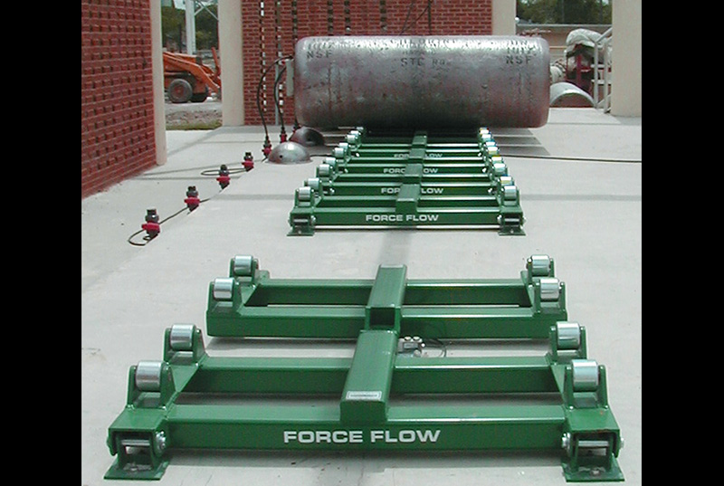
Pictured above is a standard chlorine scale and trunnion system. The trunnion acts as a form of storage while also keeping an accurate measure of the amount of chemical left in the tanks. In California, the tanks must also be secured with straps due to earthquakes.
Valves and piping are just as important in the chlorine system as they are in the water system. Each chlorine tank or cylinder is equipped with valves which allow or prohibit the flow of the chlorine during the transfer and storage of the product. In an emergency the valves can also be used to quickly shutoff the flow of chlorine. Large scale systems will include piping manifolds that allow for the transfer of chlorine from multiple tanks. The associated feed system will include valves and piping to provide chlorine to different feed points in the system.
The chlorinator is the piece of equipment that feeds the chlorine directly into the system. Chlorine is dispersed evenly into the system based on a dosage set point using vacuum and pressure regulators. For safety, a vacuum must be maintained in the line. The vacuum ensures that the chlorine is always being pulled into the chlorine feed system. Most modern systems have emergency shutoff valves which prevent the flow of chlorine if a leak is detected. Chlorine systems will also include alarms, leak detectors, and repair kits.
Other safety measures are also required when working around chlorine gas. For example, when switching tanks, the operator should be wearing a self-contained breathing apparatus (SCBA). As noted earlier, a 0.1 part per million dose of chlorine gas can be immediately fatal.

Hypochlorination
Gaseous chlorine is the strongest and least expensive form of chlorine even with the required use of bases such as caustic soda to increase the pH of the finished water. However, due to safety concerns associated with the use and transportation of gaseous chlorine, Hypochlorination is becoming more common in water treatment. When building or redesigning a treatment plant, an analysis of the costs and benefits of each type of chlorine will determine which type the facility will use.
The two types of hypochlorite used are calcium and sodium. Calcium hypochlorite is a whiteish-yellow dry chemical. It contains 65% available chlorine. Since it is highly reactive with organic compounds, special requirements must be used when storing it. Additionally it is flammable if enough heat and oxygen are added. Calcium hypochlorite should always be added to water and not the opposite. Generally, Calcium hypochlorite is primarily used for disinfecting new and repaired water mains and storage tanks. It is not used for the day-to-day treatment of finished water.
Sodium hypochlorite is a clear to yellowish liquid available in a variety of different concentrations. Household sodium hypochlorite, known as bleach, is available in a 5% solution. Treatment plant operations will use an industrial strength concentration of 12.5% available chlorine. Sodium hypochlorite does not have special storage requirements, but it is a strong base at 9-11 on the pH scale so it is highly corrosive. Additionally, the chemical loses its effectiveness over time in storage. Stored for a month, the chemical can lose 2% to 4% of its chlorine content. Direct exposure to sun and/or heat will further the loss of available chlorine. Therefore, it is recommended that sodium hypochlorite be stored no more than two weeks (in the event the treatment plant is offline) in a temperature-controlled room to prevent excessive strength loss.

Cylinder Tank Safety and Connecting
When attaching a chlorine regulator to a tank to go into service, safety precautions must be used. Any time you are dealing with gas chlorine the operator must wear a respirator, but a SCBA is recommended. The SCBA has a 30-60 minute supply of oxygen. SCBA’s operate under positive pressure, so in the event of a leak, no chlorine gas will be able to enter your mask, assuming a proper seal of the mask has been established. Along with a respirator or SCBA the operator should wear gloves and a long sleeve shirt when changing cylinders or tanks.
A new lead washer should be used every time a new tank is put into service. Inspect the lead washer for any deformities, cracks, or bends. Washers must be thrown out after one use. When the chlorine tank valve is first opened, rapidly open and close the valve. Use an ammonia solution near the valve and tubing to check for leaks. The ammonia solution used is commercial Be ammonia. If chlorine is present, you will see a white cloud. In the event of a white cloud, a leak is present. The operator will have to remove the regulator from the valve and use a new lead washer.
Lastly, be vigilant. Changing chlorine cylinders will become routine as it is something you will have to do often if your facility uses chlorine gas. Chlorine gas is a highly dangerous chemical that must be respected. Forgetting how dangerous it is, could lead to serious harm or death for you or your co-workers.

Chapter Review
- The form of Chlorine which is 100% available chlorine is?
  - Sodium Hypochlorite
  - Calcium Hypochlorite
  - Calcium Hydroxide
  - Gaseous Chlorine

- What is the minimum amount of chlorine residual required in the distribution system?
  - There is no minimum
  - mg/L
  - 0.2 mg/L
  - mg/L

- What is the approximate pH range of sodium hypochlorite?
  - 4-5
  - 6-7
  - 9-11
  - 12-14

- What is the typical concentration of sodium hypochlorite utilized by water treatment professionals?
  - 5%
  - 65%
  - 100%
  - 12.5%

- Chlorine demand refers to
  - Chlorine in the system for a given time
  - The difference between chlorine applied and chlorine residual—usually caused by inorganics, organics, bacteria, algae, ammonia, etc.
  - Chlorine needed to produce a higher pH
  - None of the above

- What is the most effective chlorine disinfectant?
  - Dichloramine
  - Trichloramine
  - Hypochlorite Ion
  - Hypochlorous acid
- What can form when chlorine reacts with natural organic matter in source water?
  - Disinfectant by-products
  - Sulfur
  - Algae
  - Coliform bacteria

- What is the maximum withdrawal rate per day for a 150-pound chlorine cylinder?
  - There is no maximum
  - 20 pounds
  - 40 pounds
  - 50 pounds

- What kind of solution is used to check for a gas chlorine leak?
  - Sodium hydroxide
  - Ozone
  - Ammonia
  - Calcium hypochlorite

- Chlorine is
  - Heavier than air
  - Lighter than air
  - Brown in color
  - not harmful to your health

- Chlorine demand may vary due to
  - Chlorine demand always stays the same
  - Temperature
  - pH
  - Both B and C

- What effect does high turbidity have on disinfection?
  - It can increase chlorine demand
  - It has no effect
  - It gives the water a milky appearance that will clear out after some time
  - You must increase the temperature of the water

Chapter 9 – Chloramination and Nitrification
The water treatment profession is constantly evolving and continuously in motion. Advancements in science and lab procedures help water professionals find constituents in drinking water that can be harmful to human beings. We take for granted the fact that clean drinking water will flow when we turn on the tap.
Currently Chlorine is the best disinfectant available. However the use of Chlorine causes any number of Disinfectant By-Products (DBPs). Many of the DBPs have not been researched and are not regularly monitored. As screening methods improve, it is likely that more of the possible DBPs will be regulated in the future. Trihalomethanes (THMs) are a DBP of Chlorine disinfection and are classified as Volatile Organic Chemicals. Rising THM levels in raw water are increasing the use of Chloramine as the preferred disinfectant. In this chapter we will discuss chloramine disinfection and the associated challenges that come with its implementation. Nothing is easy in water treatment. After reading this chapter you should be able to explain and identify the following topics:
- Why chloramine treatment has been employed, (hint) DBP formation
- The use of Ammonia in water treatment
- Breakpoint chlorination
- Nitrification

Why Use Chloramines?
As discussed, Chlorine has been used with great effectiveness in water treatment for many years in the United States. However recently, many water agencies have been switching to Chloramine treatment. Now here is the twist; they have done it because they must, not because they necessarily want to. When natural organic matter reacts with chlorine, it can result in the formation of DBPs, specifically Trihalomethanes (THM) and Haloacetic acids (HAA5). It is believed that long term exposure to these DBPs should be avoided as it may lead to cancer.
Because of the implementation of the Stage 2 DBP Rule in 2012, many water agencies could no longer meet the regulatory limits established, if they continued using chlorine as a primary disinfectant. To continue using chlorine alone, enhanced coagulation would have to be used but its effectiveness is limited. Carbon or GAC absorption is also a solution but it is very expensive, and thus not employed by larger water treatment facilities. The other option is to limit contact with the water and chlorine, but this is limited by the chlorine demand. The last and most effective option is to use chloramines.
Chloramine treatment is also effective in limiting taste and odor problems in finished water. When free chlorine reacts with phenol it can cause taste and odor issues. Chloramine disinfection is not as strong a disinfectant as free chlorine, chlorine dioxide, or ozone, but it does leave the longest lasting residual in finished water. Because of chloramines weaker disinfecting power, it is often added just before the treated water enters the clearwell for storage. If implementing this method, the operator must ensure the THM levels are low enough as not to violate any regulations. Determining the most effective way to treat drinking water while remaining in compliance is a complex and difficult task.

Chloramine Chemistry
Chlorine reacts with a number of substances in water including dissolved organic matter, particulate organic matter, iron, nitrite, sulfide, and ammonia. It reacts by taking away an electron from them. Ammonia in the water supply is undesirable as it strips away the Chlorine residual which then requires the need to use more Chlorine. What makes chloramine treatment so effective is chlorine’s quick formation with ammonia (NH₃). (Ammonia is a compound of Nitrogen and Hydrogen.)
CL₂ + NH₃ → NH₂Cl + HCl (monochloramine is expressed as NH₂Cl)
The unit weight of Chlorine is 70 and the unit weight of Nitrogen is 14. When chloramine treatment is employed, the ratio of chlorine to ammonia will always be 5:1 because 5 mg/L of chlorine will always combine with 1.0 mg/L of ammonia. (70 ÷ 14 = 5) You will often hear monochloramines referred to as combined chlorine due to this reaction.
Below is a list of terms dealing with Chloramine disinfection:
- Free Chlorine: Cl₂ (Free chlorine can refer to gaseous, sodium hypochlorite, or calcium hypochlorite.) If using hypochlorite, remember you must dose the water to achieve 100 percent free chlorine.
- Monochloramine: NH₂Cl or combined chlorine. Chloramine with the least taste and odor problems.
- Free Ammonia: NH₃ Ammonia is measured as nitrogen.
- Chlorine: Ammonia ratio: Total chlorine to total ammonia nitrogen. You will always target a 5:1 ratio to avoid excess free chlorine or free nitrogen in the water supply.

Breakpoint Chlorination
The breakpoint chlorination curve is the visual representation of chlorine’s ability to react with a variety of compounds to form a combined chlorine residual or to completely react with compounds to form a free chlorine residual. When using free available chlorine as a disinfectant we want to stay out of the combined curve. Some water agencies buy imported water that has a combined residual. To treat the water more effectively or eliminate the possibility of nitrification, some of these agencies add chlorine to “break” over to a free chlorine residual. We will discuss Nitrification in greater detail later in this chapter.
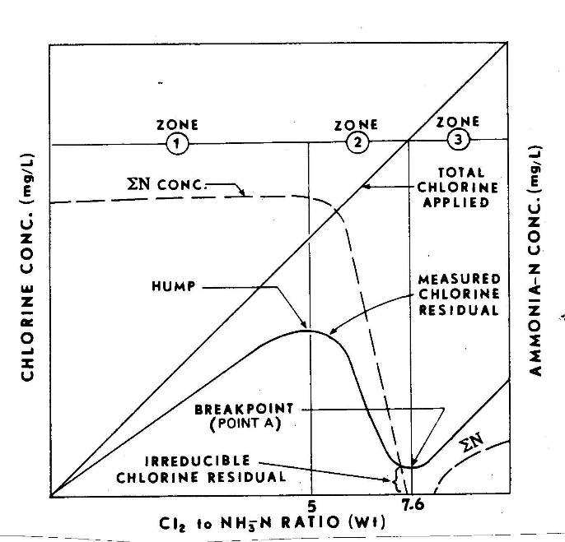
The breakpoint chlorination curve. This curve represents chlorine’s ability to have either a combined residual or a free residual. – Image by the NSW Department of Premier and Cabinet is licensed under CC BY 4.0
A common problem that operators run into when using combined chlorine is “breaking over” to free chlorine by misdiagnosing problems on the treatment plant. For example, an operator is looking at a Supervisory Control And Data Acquisition (SCADA) screen. (SCADA is the computer system that monitors and controls the plant.) For the sake of ease, we will call this operator #1. He or she notices the chlorine effluent residual is beginning to drop. Operator #1 was not aware that the previous operator (Operator #2) had raised the chlorine dose a few hours before. With the added chlorine dose, the chlorine residual was “lowering” as it got closer to breaking over. If operator #1 panics and raises the chlorine dose again the combined chlorine residual will lower even further.
The important thing to remember is there are many things to look at if your chlorine dose is lowering. It may very well be an issue with your chlorine feed, but there are many other options to consider. If you check your chlorine feed system and everything is functioning normally, you may have an issue with the ammonia feed system. Many modern water treatment facilities have calculations built into the SCADA system that make chloramine dosing easier. Make sure to go to the screen with the chlorine: ammonia: ratio to make sure that it is set up correctly.
Lastly, free chlorine is always the preferred disinfectant as it is 25 times stronger a disinfectant than chloramines. However, chloramines last much longer in the distribution system. There are several factors that may lead to a lowered chlorine residual. An increase in biological growth is possible, but you should see other signs such as an increase in turbidity. The most common problem in chloramine treatment with a decreasing chlorine residual is operator error or an issue with the water treatment process.

Nitrification
Nitrification is a process in which bacteria reduces ammonia and organic nitrogen in treated water into nitrate and then nitrite. This condition usually occurs during the summer months when water temperatures are higher. It can also occur during the improper turnover of reservoirs, when there are high levels of ammonia, and in dark environments, a typical condition for most water reservoirs.
This condition is one of the drawbacks of chloramine treatment. Nitrate and Nitrite are inorganic chemicals regulated by primary drinking water standards. The MCL (Maximum Contaminate Level) for Nitrate is 10 ppm and the MCL for Nitrite is 1 ppm. High nitrate and nitrite levels in drinking water can lead to methemoglobinemia also known as “blue baby syndrome.” This condition effects infants under six months old that consume water contaminated with nitrates and nitrites. The infants blood is not able to carry enough oxygen to blood cells and tissue within their body.
The condition of Nitrification is a reoccurring cycle that can lead to the total loss of chloramine residual in the distribution system and in water storage tanks. If this was to occur, all the water in the system would have to be dumped and it would be a total loss. As an operator, this is something that you never want to happen. Not only would it be a loss of money for your company, but it could lead to an outbreak of methemoglobinemia. The cycle is below:
Chloramine decay→ Release of ammonia→ oxidation of ammonia to nitrite from oxidizing bacteria → Biomass increase → (back to chloramine decay until there is a possibility of total loss of residual)
Some early indicators of nitrification:
- Lowering chloramine residual
- Increase in bacterial heterotrophic plate counts
- Excess ammonia in the treated water
- Total coliform positive samples
In summation, nitrification can cause a variety of problems and violations within the water system. What can we as operators do to minimize any chance of nitrification from occurring? There are a few steps every operator can take to avoid nitrification. First, you want to minimize free ammonia in treated water. Sampling and equipment around the treatment plant will help operators determine if there is too much free ammonia in the treated water.
Second, operators should always maintain a good chlorine residual. Isn’t that the name of the game? Sure, but it is easier said than done in some cases. Many water treatment companies will lower their target chlorine residual in the summer to save on costs because the disinfectant works more efficiently during the summer months. It is a good practice in theory, but not necessarily the best practice if you are working with chloramines and trying to combat nitrification.
Reducing water age is the third step operators can use to combat nitrification. This can be done by cycling reservoirs during the summer months and taking reservoirs out of service during the winter when water demands are lower. Distribution operators are continually balancing maintaining a good amount of water for fire flow and demand, but also cycling reservoirs to fight nitrification. A good practice is to take all the reservoirs in the distribution system and divide it into thirds. At any given point during the day 1/3 of the reservoirs are full, 1/3 are in the middle range, and 1/3 are in the lower range. This allows operators to cycle water while also keeping water in the system.
The last step is to keep the water system clean. This can be accomplished by flushing dead ends to prevent lower chlorine residuals at the end of the distribution system. Boosting chlorine by adding it directly to a reservoir is also an option but not always the best practice. The problem with this method is it could lead to short circuiting. Chlorine must mix adequately to be effective. Mixing can be accomplished by adding mechanical mixers in the reservoir to keep water moving and prevent short circuiting. Chlorine can also be added to the inlet of the reservoir so the water pressure acts as a mixer.
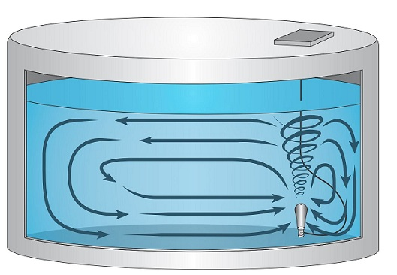
Picture above is an example of a water reservoir mixer used to cycle water and prevent short circuiting.
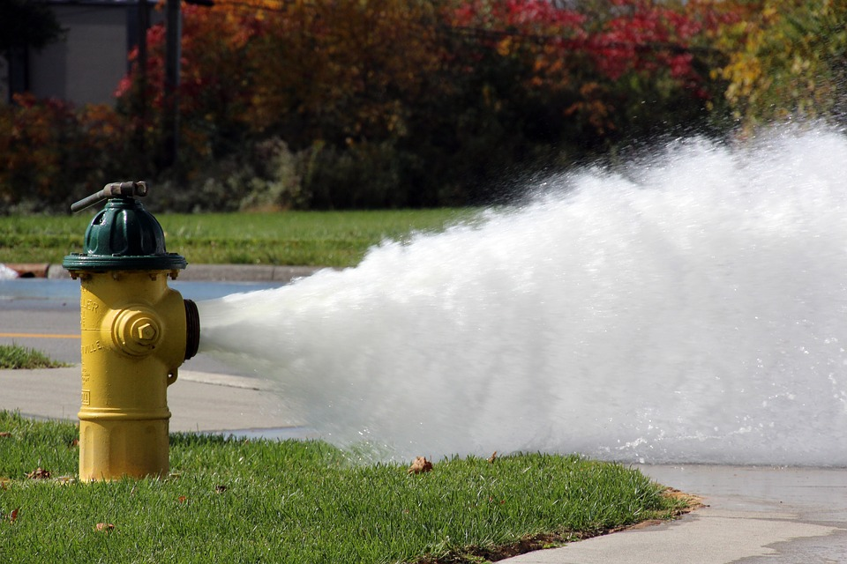
Hydrant flushing is a method that can be used to get rid of stagnant water at the ends of a distribution system. Stagnant water can lead to lower chlorine residuals and possible nitrification. – Image is licensed under CC0
In summary, the use of Chloramines as a disinfectant is being employed by many water agencies in the United States to prevent DBP formation. It is not the most ideal disinfectant available, but it does have some advantages. Chloramine disinfection limits DBP formation and has a longer lasting disinfectant residual. This can be useful for larger systems where water must travel great distances to get to storage.
The drawbacks include the difficulty in effectively managing the breakpoint chlorination curve and managing nitrification. Because of advancements in water quality testing and more stringent regulations with DBPs, chloramine treatment is and will continue to be a more popular option in water treatment.

Chapter Review
- What is the target chlorine:ammonia ratio?
  - 2:1
  - 3:1
  - 4:1
  - 5:1

- What is the MCL for Nitrates?
  - 1 ppm
  - 10 ppm
  - 5 ppm
  - None of the above

- What is the atomic weight of Chlorine?
  - 70
  - 14
  - 65
  - 20

- What disinfectant has the longest lasting residual?
  - Ozone
  - Chlorine
  - Chloramine
  - Chlorine Dioxide

- What are some of the early indicators of Nitrification?
  - Lowering chlorine residual
  - Excess ammonia in treated water
  - Raise in bacterial heterotrophic plate counts
  - All of the above

- What are THMs classified as?
  - Turbidity
  - Radiological
  - Volatile Organic Chemicals
  - Salts

- What method can operators employ to combat nitrification?
  - Lower residual chlorine target
  - Keep reservoir levels static
  - Minimize free ammonia in treated water
  - Increase water age

- How many times stronger is Chlorine compared to monochloramine?
  - 25 times
  - 20 times
  - 15 times
  - 5 times

Chapter 10 – Laboratory
Working in a laboratory is probably something you never thought about when deciding to explore the career of water treatment. However, working in a laboratory is one of the more critical aspects in the profession. Many larger agencies have a dedicated staff of laboratory personnel that handle a lot of the day to day water quality analysis, but operators still play a key role. After all, the operator is the person in charge of running the plant, monitoring chemical feeds, and performing routine plant checks to ensure the system is running smoothly. A laboratory scientist can run all the tests in the world, but since they are not the ones running the plant, a lower chlorine residual may not stand out to them. The responsibility falls squarely on the shoulders of the operator. State regulations require operators to take grab samples throughout the day to ensure monitoring equipment throughout the plant is running correctly. After reading this chapter you should be able to identify and explain the following topics related to treatment plant laboratories:
- Equipment in the laboratory
- Laboratory safety
- Water quality testing
- Contaminants tested in the laboratory and throughout the treatment plant
This topic is discussed at length in the water quality course. This is meant to be a brief overview if you have not taken that course yet.

Laboratory Instruments and Equipment
Throughout the lab you will find a variety of beakers, flasks, dilution bottles, and graduated cylinders. A lot of these instruments look the same or similar but they all have a unique job and purpose. Beakers range in size from 25 to 4000 mL. They are used to mix samples during chemical analysis. A burette is a long skinny tube-like glass receptacle used to measure and disperse liquid. Flasks have a narrow neck and are round at the bottom. Each kind of flask serves a different purpose, but they all look very similar.
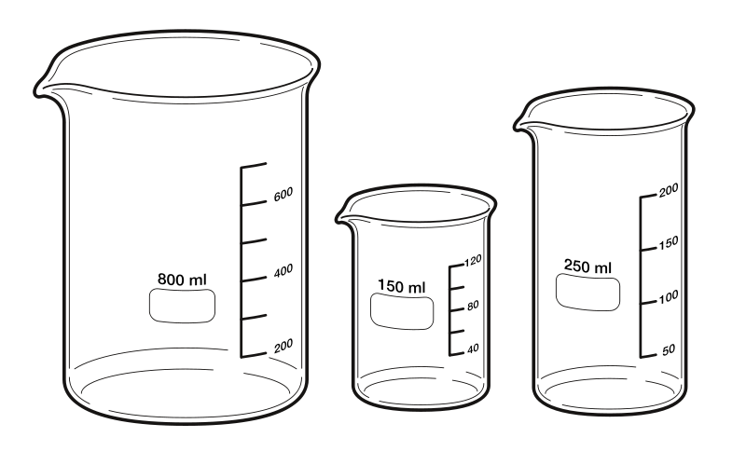 | 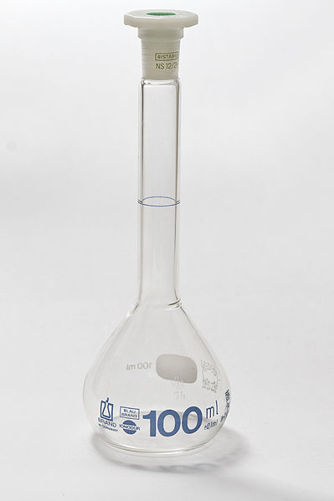
Beakers – Image by Xavax is in the public domain | Volumetric flask – image by Lucasbosch is licensed under CC BY-SA 3.0
Graduated cylinders are tall and cylindrical and range in size from 10 mL-4000 mL. They are used to measure liquid, but not with accuracy. For example, they can be used during a chlorine test to gather a general volume of water. If you need an exact amount, it should be measured with a pipette or other similar and accurate liquid measuring device. The pipette measures a liquid with 100 percent accuracy.
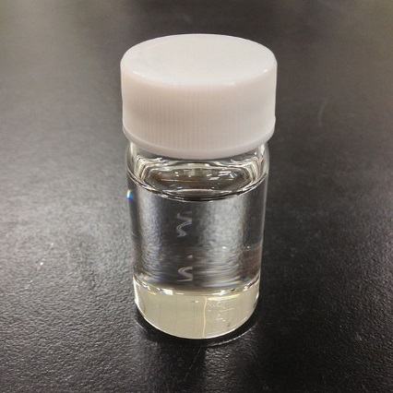
Sample Bottle – image by Σ64 is licensed under CC BY-SA 3.0
You will find sample bottles in any laboratory. The bottles can be made of plastic or glass. They are used to store water for future lab tests and not used for measuring liquid. Sample bottles are used to collect bacteriological samples and for organic chemical analysis. The bacteriological bottle is one of the most important sample bottles you find in a lab. They are made of plastic and are 100 mL. Water treatment operators must take bacteriological samples per the Total Coliform Rule. These tests will be performed daily in the lab and throughout the distribution system based on your coliform sampling plan.
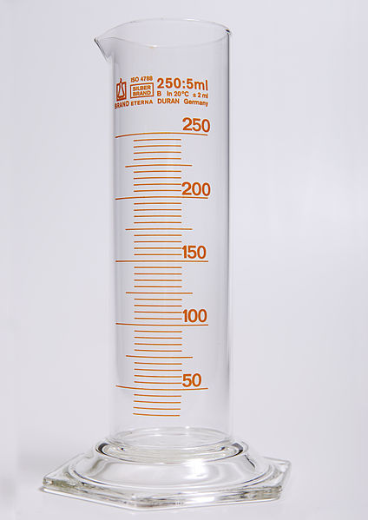 | 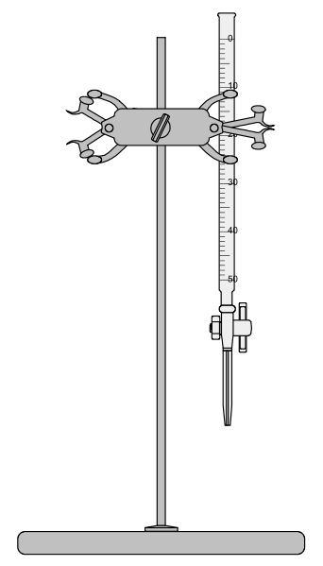
Graduated Cylinder – image by Lilly_M is licensed under CC BY-SA 3.0 | Burette – image by Roland1952 is licensed under CC BY-SA 3.0

Other Items Found In the Laboratory
Incubators will be found in every lab at a water treatment plant. They are used to hold a temperature for bacteriological cultures. There are two types of incubators used, dry heat and water baths. Common uses for incubators include coliform testing, multiple tube testing, and heterotrophic plate counts. Ovens are other pieces of equipment found in the lab. Autoclaves, for example, are used to sterilize glassware items but can also be used to sterilize material that has been contaminated from perhaps a positive coliform test. Refrigerators are used to store samples for future testing and to store chemicals used for water quality testing. These refrigerators are for work use only and should not be used to store food and beverages.

Laboratory Safety
Operators should always be aware of safety regardless of where they are at the treatment plant. The laboratory should be treated no differently than if an operator was changing chlorine cylinders. There are chemicals that are combustible and others that can cause severe burns if they are exposed to skin. Some common safety equipment found in water treatment plant laboratories:
- Eye protection- eye protection should include safety goggles, safety glasses, or face shields. It is not recommended to wear contact lenses if working with dangerous chemicals. Prescription safety eyewear is available. You only have one set of eyes, so it is important to protect them. Water laboratories have liquids and solids that can easily penetrate your eyes if you are not wearing the proper PPE (personal protective equipment).
- Safety Showers/Eyewash Bottles- In the event something gets in your eyes, every lab is equipped with a safety shower. The shower should have a pull lever and an eye wash sink.
- Fire Extinguisher- Fire extinguishers are located throughout any building in the United States. Most water treatment companies will provide formal training on proper use of a fire extinguisher. In the event you cannot put a lab fire out with the use of an extinguisher, exit the room right away and call the fire department. Fire extinguishers are meant to put out very small fires very quickly.
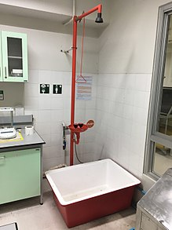
Emergency eyewash and shower – Image by Korn966 is licensed under CC BY-SA 4.0Meters
Laboratories use a variety of meters for water quality testing. Although meters are located throughout the treatment plant, the meters in the lab are used to verify that equipment throughout the treatment plant is functioning correctly. The most common meters used by water treatment operators are pocket colorimeters for chlorine testing in the field, turbidity meters, and pH meters. Pocket colorimeters are great to be used in the field, but the results are not reportable. For compliance purposes you must use an electric colorimeter or photometer.
pH meters and turbidimeters are used to verify equipment is working throughout the plant. At a minimum an operator will run labs on turbidity, chlorine residual, water temperature, and pH. All of these parameters are required for CT compliance and verification. These measurements are important in ensuring the treatment plant is operating in compliance with the surface water treatment rule.

Microbiological Testing
Microbiological testing is probably the most important testing done by water treatment professionals. As discussed at length in this text, treatment water operators aim to remove and deactivate pathogenic organisms from drinking water through filtration and disinfection. Water regulations require 3Log removal and deactivation of Giardia and 4 log removal and deactivation of viruses. Bacteria fall in the middle of Giardia and viruses. Therefore, it is safely assumed bacteria will be removed and deactivated along the same process.
Water professionals test for microbiological agents by testing for the indicator organism coliform. Coliform bacteria cause no harm to humans but are generally present when pathogens are present in the water. The reason coliforms have been used to identify contaminated water for over 100 years is because they are always present in contaminated water. Even if there is no fecal contamination, they are still present. They survive longer in water than pathogens and they are easy to identify with proper testing. When a positive sample is identified, we assume the water is contaminated until it can be proven otherwise.
Water treatment facilities use four different tests for coliform monitoring. The easiest, least expensive, and the most common method for coliform testing is the presence absence test (P-A). Both the P-A and multiple tube fermentation (MTF) tests work based on the fact that coliform produces gas from the fermentation of lactose within 24-48 hours. The MTF method uses three steps for the test. It includes the presumptive, confirmed, and completed test cycle. The presumptive test is accomplished in 24 hours. Samples are incubated at 35 degrees Celsius for 24 hours and then checked to see if a gas bubble has formed or if the sample is cloudy. You want to see no bubble or gas. The samples are then incubated for another 24 hours. If gas does not form, the test is over and the sample is absent. If there is a gas bubble, you move on to the confirmed test.
The confirmed test verifies the sample is positive from coliform and not another type of bacteria. Brilliant Green Lactose Vile is added to the sample and then incubated for another 48 hours. The same method is used. The lab technician or operator checks to see if gas is produced during the incubation period. The minimum requirement for water treatment operations is the presumptive and confirmed test. The completed tests are rarely used except for quality control by laboratory personnel. In the event of a positive confirmed test, coliform bacteria violation protocol will go into effect.
The P-A method is the most common method for treatment operators and field sampling staff. The bottles are easily transferred in an ice chest and the set-up is very simple. This method is commonly referred to as the Colilert method. The test uses a 100 mL plastic sample bottle. A nutrient is added to the sample, which is then incubated for a period of 24 hours at 35 degrees Celsius. The nutrient will cause the water to turn yellow if coliforms are present. In the event of a positive test, the bottle can be placed behind a fluorescent light that will turn a blue color which indicates fecal E. coli contamination.
The other two bacteriological tests include MMO-MUG and the membrane filter method. The MMO-MUG tests come with the testing agent already in the vials. A 10 mL sample is simply added to the vial. As with the P-A test, samples positive for coliform will turn yellow and for fecal contamination will turn blue. The membrane process begins with filtering 100 mL of water through a membrane filter. Then the sample is added to a petri dish and incubated for a 24-hour period. Coliform positive samples turn a red-pink color. Confirmative tests require incubation of a broth for another 24 hours.

Physical Water Quality
Operators test the water for both physical properties and contaminants that will cause harm to humans. There are secondary standards related to many of the physical tests operators perform. Acidity is the ability to neutralize a base. Alkalinity is the ability of water to neutralize acid. The reason operators are concerned with the acidity and alkalinity of drinking water is different pH scales have different effects on water treatment. When acids are added to water, they lower the pH of the water. A strong base may need to be added to boost the pH. Operators want a small amount of calcium carbonate present in the water to deposit around the pipes of the distribution system. This helps combat corrosion.
When we think of water drinkability, we might think of color, taste, odor, and temperature. The physical aesthetic of the water matters and impacts our desire to drink the water. The color of the drinking water may indicate water with higher levels of organic compounds and water with THMs.
Taste and odor issues in treated drinking water are hard to test. Many customers complain of a strong chlorine smell in their drinking water. Taste and odor problems can come from organic matter, chlorine, dissolved gases, and even industrial wastes. The threshold odor test is measured on the TON scale. (Water sample of 100 mL + dilution divided by 100 = TON.) Water registering as a 3 will most likely draw complaints from customers.
Water temperature plays a key role in water treatment because disinfectants work better at higher temperatures. However, nitrification occurs during the warmer months of the year so the water temperature has to be carefully managed. Water agencies in colder regions of the country must deal with freezing conditions within their treatment and distribution system. During the winter even in warmer regions, lake turnover can cause vast changes in water quality.
Turbidity is the suspension of particles in water. High levels of turbidity can signify major issues within the treatment plant. Therefore, turbidity is used to verify how efficiently the treatment plant is operating. High turbidity values may indicate higher levels of organic and inorganic matter. Pathogenic organisms can hide behind turbidity and render disinfection ineffective. Turbidity is measured in the lab with a nephelometric counter. A light source is added and in the presence of turbidity the light scatters producing higher numbers with greater amounts of turbidity.
The final two water quality testing procedures most commonly performed by water treatment operators are chlorine and pH. The chlorine or chloramine feed system is one of the most critical components of a water treatment plant that operators monitor through online testing and grab samples.
The measurement of the hydrogen ion concentration in water is pH. The pH scale ranges from 1- 14 with 1 being the most acidic and 14 the most basic. The higher ends of both ranges produce the most corrosiveness. 7 is considered neutral. Do not confuse pH with acidity or alkalinity. It is important to monitor pH because the pH is used to control many chemical reactions in the treatment plant including coagulation, disinfection, corrosion control, and the removal of ammonia. pH also plays a key role in the CT calculation.

Chapter Review
- An organism used to indicate the possible presence of E. coli contamination is _______.
  - Cryptosporidium
  - Giardia
  - Coliform
  - Brilliant Green Vile

- The presence-absence (P-A) test used for microbiological testing is also commonly referred to as ___.
  - Multiple Tube Fermentation
  - Membrane Filtration
  - Confirmed Test
  - Colilert

- When testing for coliform bacteria with the multiple tube fermentation (MFT) method what is the best indicator for a positive test?
  - Color change
  - Gas bubble formation
  - Formation of a cyst
  - Formation of turbidity

- Coliform bacteria share many characteristics with pathogenic organisms. Which of the following is not true?
  - They survive longer in water
  - They grow in the intestines
  - There are less coliform than pathogenic organisms
  - They are still present in water without fecal contamination

- What is the second step in the multiple tube fermentation test?
  - Presumptive test
  - Negative test
  - Completed
  - Confirmed

- What is the removal and deactivation requirement for Giardia?
  - 2 Log
  - 3 Log
  - 4 Log
  - There is no requirement

- The multiple barrier approach to water treatment includes removal through which method?
  - Filtration
  - Coagulation
  - Disinfection
  - a and c

- A pH reading of 7 is considered _______.
  - Slightly acidic
  - Acidic
  - Basic
  - Neutral

- A higher than normal turbidity reading could signify ________
  - A change in water quality
  - Nothing. Keep operating as normal
  - Microbiological contamination
  - Both A & C

- What is the ingredient used during the second multiple tube fermentation test?
  - Colilert
  - MMO/MUG
  - Brilliant Green Vile
  - Chlorine

